**NAME**: SATHYAPRAKASH SAHOO

**ROLL NO** – CS-4124 **DIV** - 2

**CLASS** – TY BSC CS **BATCH** – C

CLOUD COMPUTING PRACTICAL JOURNAL

**PRACTICAL NO – 1**

**Study and implementation of Infrastructure as a Service.**

Iaas is also known as Hardware as a Service (HaaS). It is one of the layers of the cloud computing platform. It allows customers to outsource their IT infrastructures such as servers, networking, processing, storage, virtual machines, and other resources. Customers access these resources on the Internet using a pay-as-per use model.

In traditional hosting services, IT infrastructure was rented out for a specific period of time, with pre-determined hardware configuration. The client paid for the configuration and time, regardless of the actual use. With the help of the IaaS cloud computing platform layer, clients can dynamically scale the configuration to meet changing requirements and are billed only for the services actually used.

IaaS cloud computing platform layer eliminates the need for every organization to maintain the IT infrastructure.

IaaS is offered in three models: public, private, and hybrid cloud. The private cloud implies that the infrastructure resides at the customer-premise. In the case of public cloud, it is located at the cloud computing platform vendor's data centre, and the hybrid cloud is a combination of the two in which the customer selects the best of both public cloud and private cloud.

**IaaS provider provides the following services -**

1. Compute: Computing as a Service includes virtual central processing units and virtual main memory for the Vms that is provisioned to the end- users.
2. Storage: IaaS provider provides back-end storage for storing files.
3. Network: Network as a Service (NaaS) provides networking components such as routers, switches, and bridges for the Vms.
4. Load balancers: It provides load balancing capability at the infrastructure layer

**Advantages of IaaS cloud computing layer**

There are the following advantages of IaaS computing layer -

1. Shared infrastructure

IaaS allows multiple users to share the same physical infrastructure.

1. Web access to the resources

Iaas allows IT users to access resources over the internet.

1. Pay-as-per-use model

IaaS providers provide services based on the pay-as-per-use basis. The users are required to pay for what they have used.

1. Focus on the core business

IaaS providers focus on the organization's core business rather than on IT infrastructure.

1. On-demand scalability

On-demand scalability is one of the biggest advantages of IaaS. Using IaaS, users do not worry about to upgrade software and troubleshoot the issues related to hardware components.

**Disadvantages of IaaS cloud computing layer**

1. Security

Security is one of the biggest issues in IaaS. Most of the IaaS providers are not able to provide 100% security.

1. Maintenance & Upgrade

Although IaaS service providers maintain the software, but they do not upgrade the software for some organizations.

1. Interoperability issues

It is difficult to migrate VM from one IaaS provider to the other, so the customers might face problem related to vendor lock-in.

**Some important point about IaaS cloud computing layer**

IaaS cloud computing platform cannot replace the traditional hosting method, but it provides more than that, and each resource which are used are predictable as per the usage.

IaaS cloud computing platform may not eliminate the need for an in-house IT department. It will be needed to monitor or control the IaaS setup. IT salary expenditure might not reduce significantly, but other IT expenses can be reduced.

Breakdowns at the IaaS cloud computing platform vendor's can bring your business to the halt stage. Assess the IaaS cloud computing platform vendor's stability and finances. Make sure that SLAs (i.e., Service Level Agreement) provide backups for data, hardware, network, and application failures. Image portability and third-party support is a plus point.

The IaaS cloud computing platform vendor can get access to your sensitive data. So, engage with credible companies or organizations. Study their security policies and precautions.

**PRACTICAL NO – 2**

**Installation and Configuration of virtualization using KVM.**

Step 1 : #sudo grep -c "svm\|vmx" /proc/cpuinfo

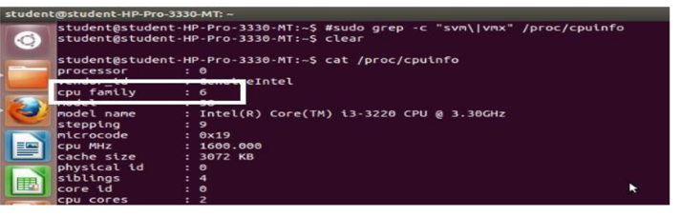

Step 2 : #sudo apt-get install qemu-kvm libvirt-bin bridge-utils virt-manager

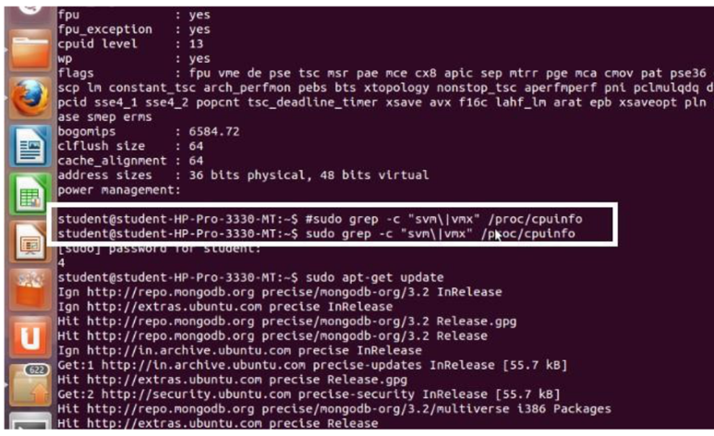

Step 3 : #sudoadduserrait

After running this command, log out and log back in as rait

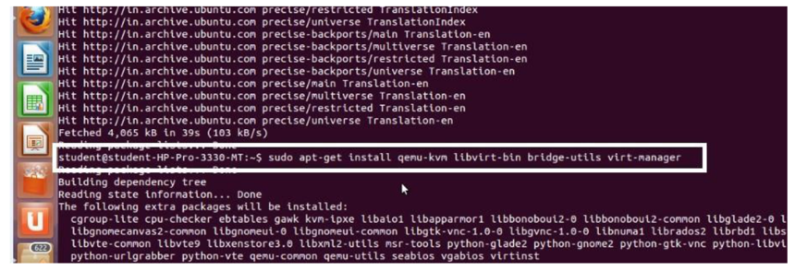

Step 4 : #sudoadduserraitlibvirtd

After running this command, log out and log back in as rait

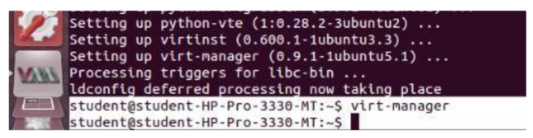

Step 5 : Open Virtual Machine Manager application and Create Virtual Machine

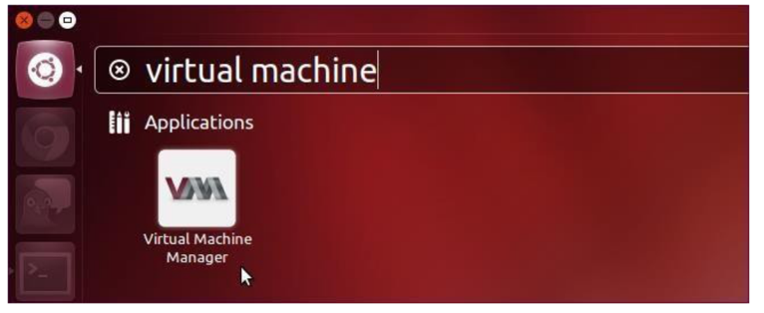

Step 6 : Create a new virtual machine as shown below

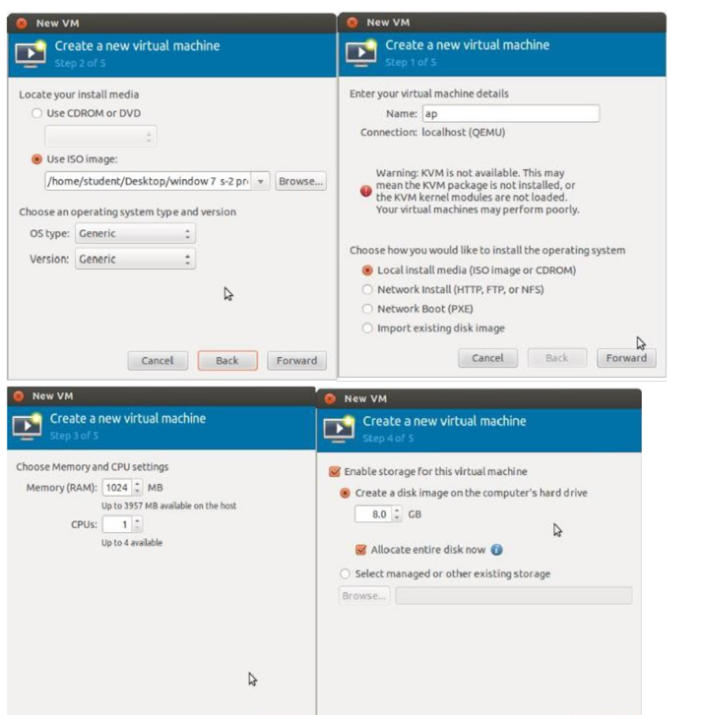

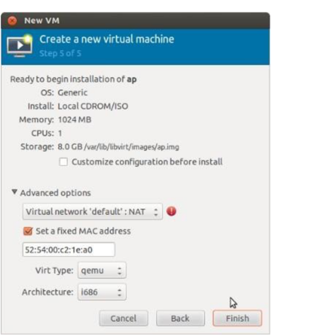

Step 7 : Install windows operating system on virtual machine

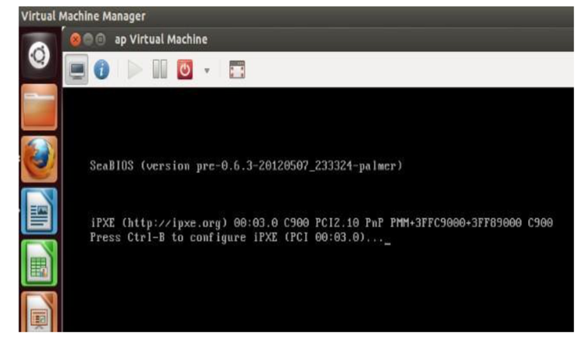

Step 8: Installation of windows on virtual machine

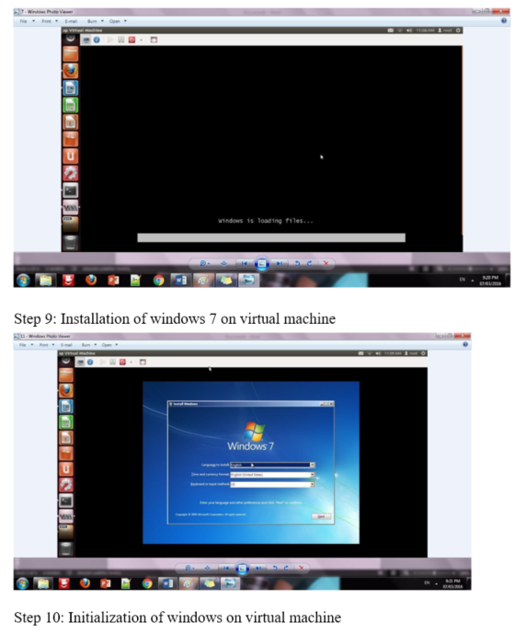

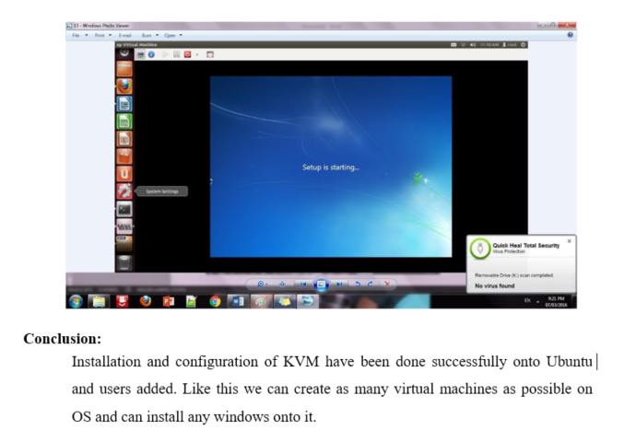

**PRACTICAL NO – 3**

**Study implementation of infrastructure as a service**

Steps :

1. Download the OwnCloud X Server from the link below :

(It only works with 64 bit system)

https://owncloud/download

2. Once you visit the above link click on “DOWNLOAD”

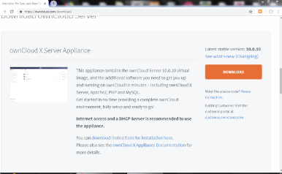

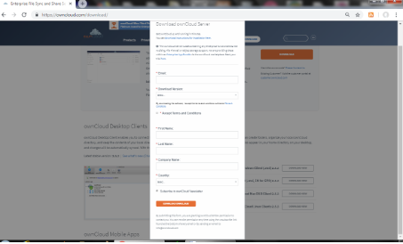

1. Select “owncloud Server Application(VMWare)”in “Download Version”drop-down list.

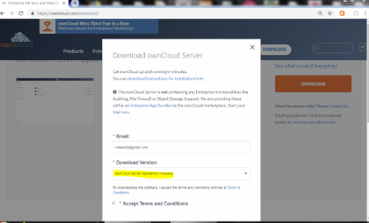

1. Fill up other details and click “DOWNLOAD OWNCLOUD”
2. Extract it, you will get virtual machine file name as “UCS”

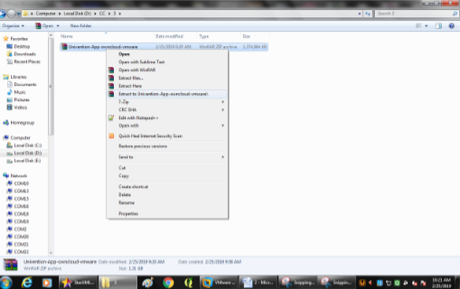

1. Open VMWare & click on”Open a Virtual Machine”

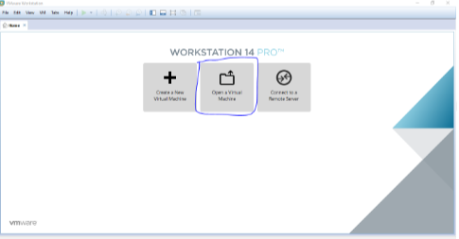

1. Select”UCS” and click open

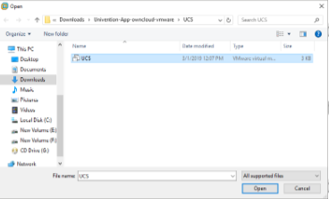

1. Click on “Power on this Virtual Machine”

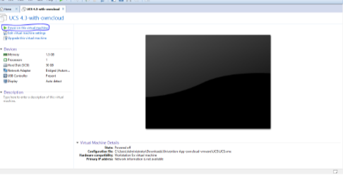

1. Following window will appear.

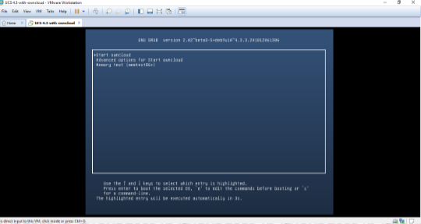

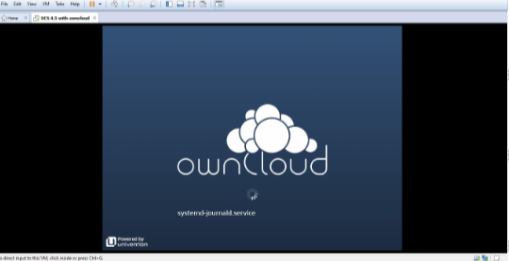

1. On next window it will ask you for your city ,don’t enter any city name in it and just click “NEXT”.

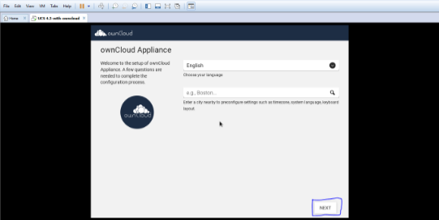

1. Just click next on “localiztaion settings” window.

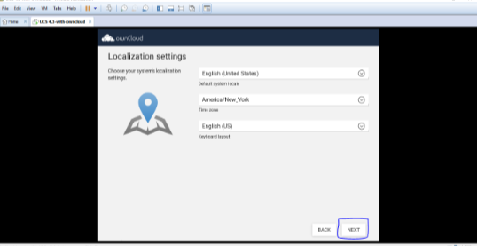

1. It will fetch IP address,NetMask and Gateway from DHCP

,don’t change anything and just click “NEXT”.

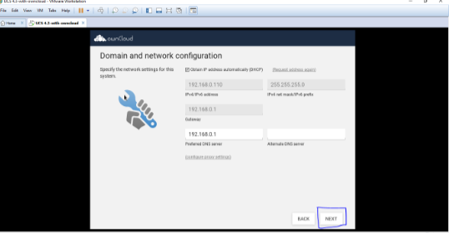

1. In Domian setup click”NEXT”.

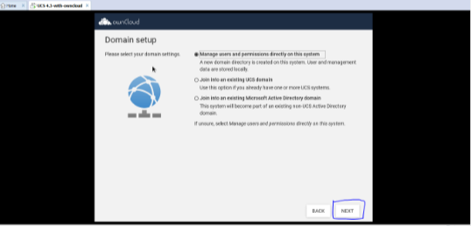

1. Now account info.  Window will appear ,enter details in it .Remember the password we are setting is for “root “ and “administrator”,click on “NEXT”

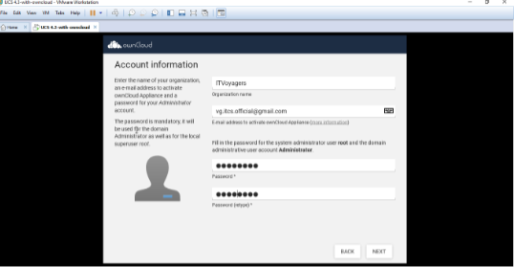

1. On next window it will show Fully Qualified Domain name and LDAP Base ,click on “NEXT”

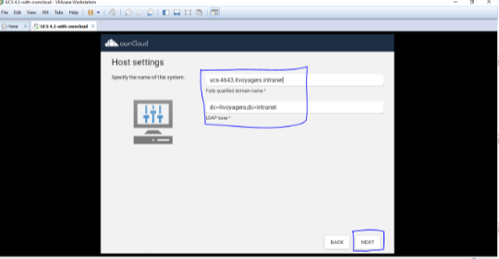

1. It will show the config. Settings for owncloud scroll down

 A little and check on “CONFIGURE SYSTEM”

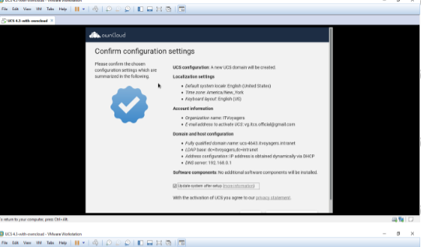

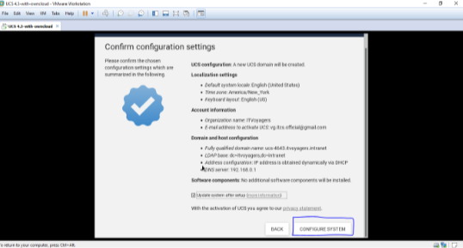

1. It will take time to setup.

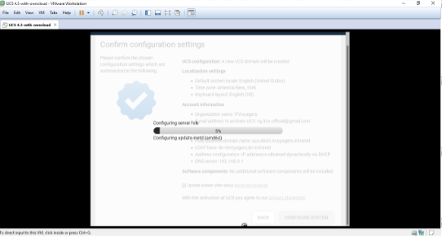

1. Yes setup is done now click on Finish.

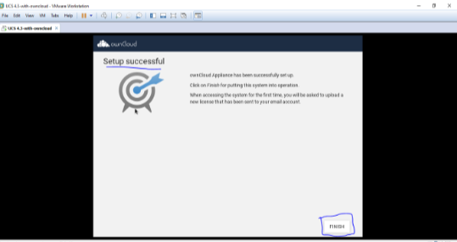

1. Now on next window press any button

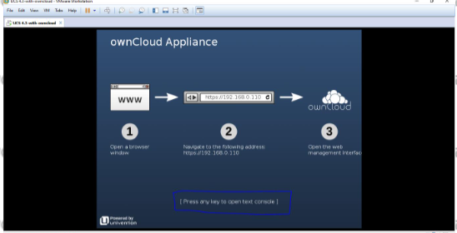

1. Now you can see IP Address on top right hand side ,open the browser and enter system’s IP address in URL bar and press enter.

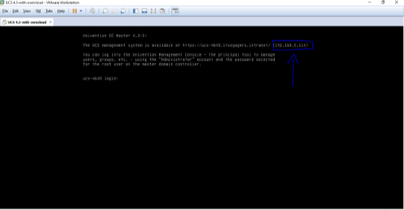

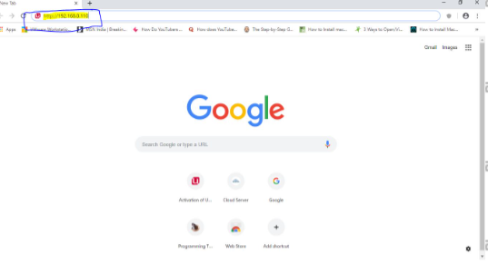

1. It will ask you for Email Id to send you license ,enter your Email ID and click “REQUEST ACTIVATION”

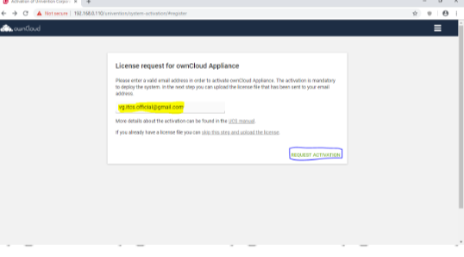

1. Check your mail box you will recieve the license from owncloud,download it.

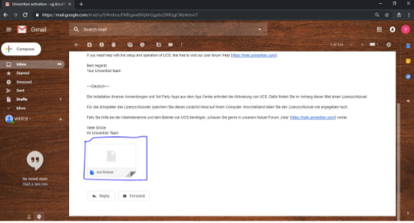

1. Get back to OWNCLOUD and click on  “Upload license file”

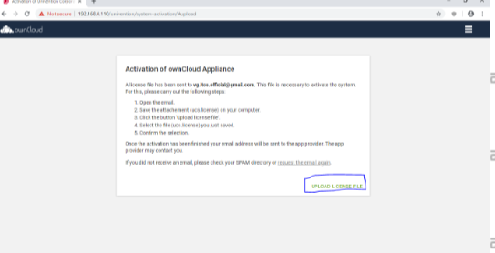

1. Now the select the license file and click open.

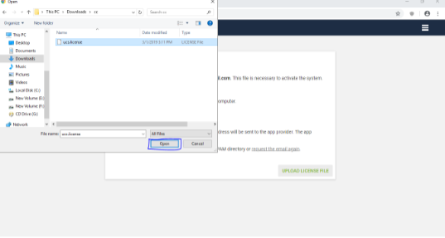

1. On next page click “FINISH”

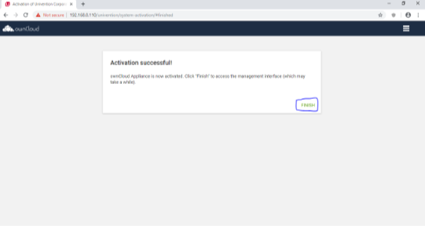

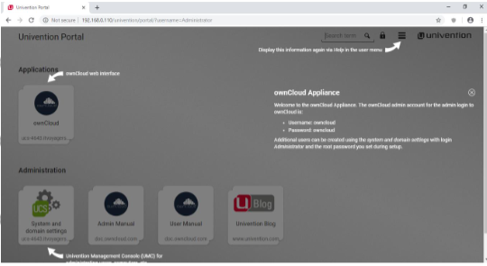

1. Now we have installed Owncloud ,just try logging in as Administrator as user for that click on  button.

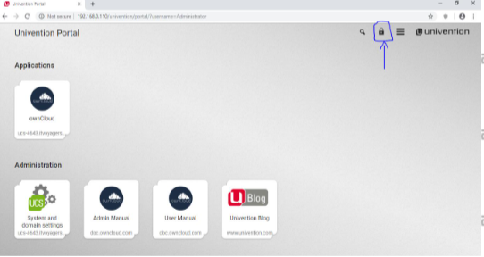

1. Enter administrator as username and the password which you set during the setting up process and click on “Login”

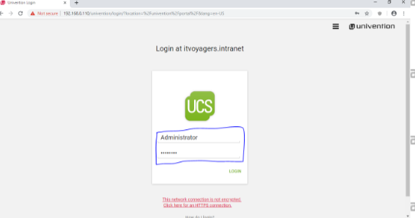

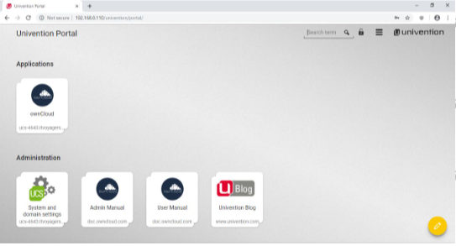

1. Now we have logged in successfully ,now click on  button.

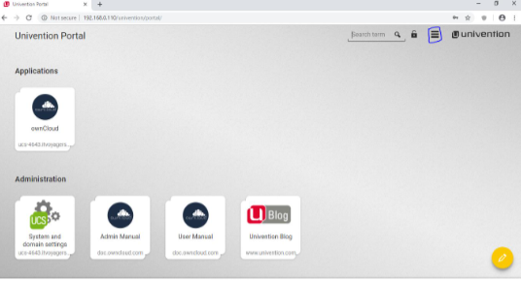

1. Now we successfully installed OWNCLOUD .

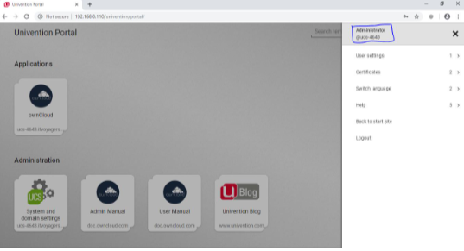

**PRACTICAL NO – 4**

**Study and Implementation of storage as a service**

1. Download own cloud from link given below.

<https://drive.google.com/open?id=1WGgFzxnbQkpOi_oHkeR2GTqNL8vkyo2>

1. We also need XAMPP Server,you can download it from given link below.

<https://www.apachefriends.org/download.html>

first install xampp server.

1. Once you download OwnCloud,you will get the zip file, extract it in “C:\xampp\htdocs”
2. Now open XAMPP control panel and start the Apache and MySQL services.

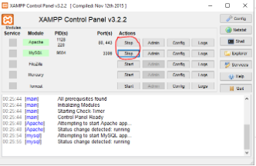

Now go to browser and enter “<http://localhost/phpmyadmin/>   in URL bar.

We can see there is no database created for for OwnCloud.

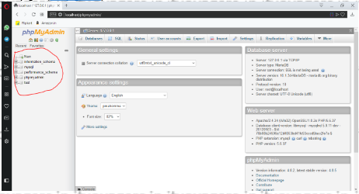

1. Now by default password  there is no password for root. We have to set the password for root for that go to “User accounts”.

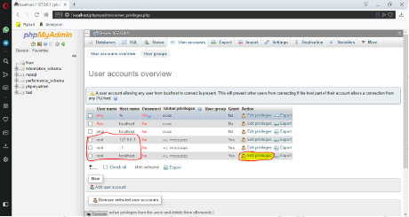

We can see that root user can be logged in through three different hosts and those are: “127.0.0.1” , ”::1” and “localhost”.

To set the password we have to click on “Edit privileges”. First we will set password for localhost.

1. Click on “Edit privileges”.

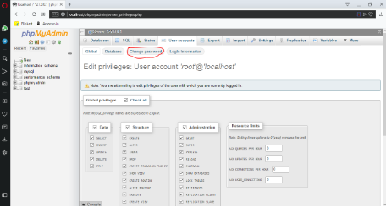

1. Click on change password.

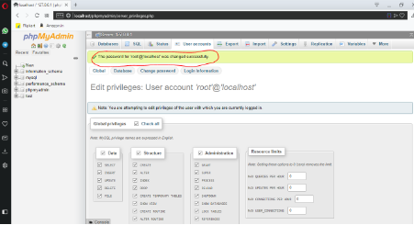

Password has been changed, but now it will not allow you to perform other operations. Even if you just refresh the page, you will see following results.

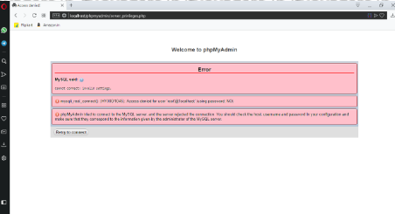

This is because it doesn’t make any changes in “config.inc.php” file.

1. We have to do it manually for that open XAMPP Control Panel go to “Config” in “Apache”

and select “phpMyAdmin(config.inc.php)”.

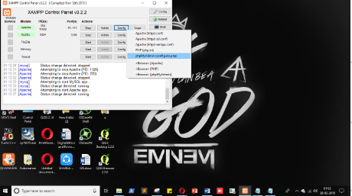

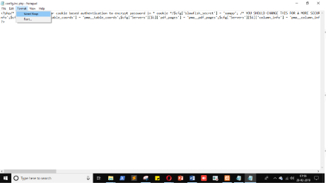

1. We are searching for “$cfg[‘Servers’][$i][‘password’]=”, just enter the same password which you just set for root user in phpMyAdmin panel, save it and close it.

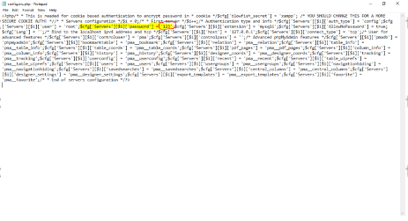

Now go to browser and refresh it.

1. Now please apply password for remaining  to root account i.e. for host “127.0.0.1” and “::1”.

Once you finish it you will see the below screen.

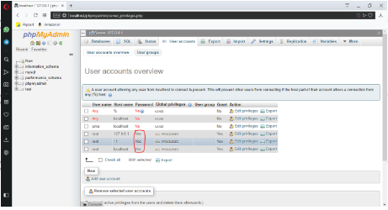

1. Now we are going to create database for our cloud. Click on “Databases”.

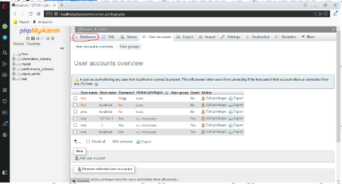

1. Enter name for database and click “Create” (even if you entered name in upper case MySQL will convert it into lower case).

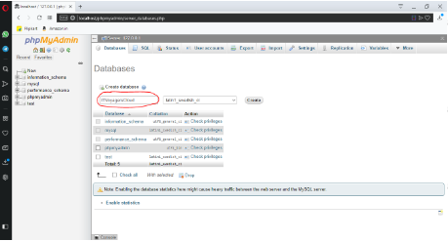

Our database is created.

1. First click on “Home”.

1. Once our database is created, we have to add user, for that click on “User accounts”.

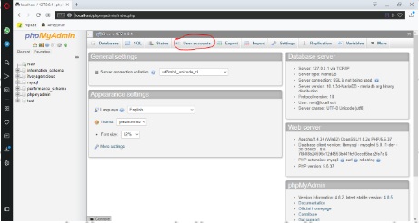

1. Click on “Add user account”.

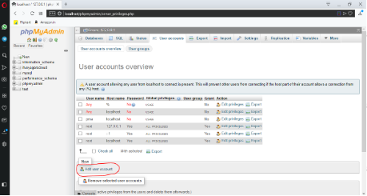

1. Set the “User name”, “Host name” and “Password” for the user, and now scroll down a little you will see “Global privileges” section.

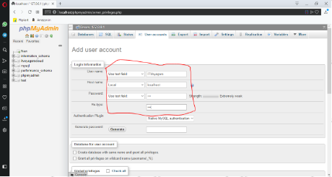

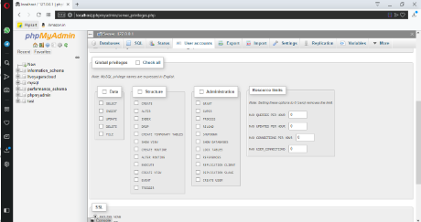

Just check “Check all” checkbox.

1. Scroll down a little more and click on “Go” on the bottom right of the page.

Now on next window we can see “Database” button, we have to assign database to the user, for that click on “Database”.

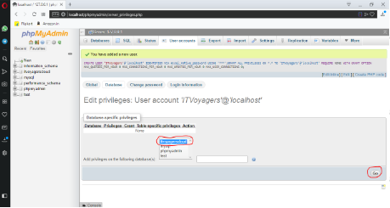

Select the datable you just created and click on “Go”.

1. It will ask for “Database-specific privileges” just check “Check all” checkbox and click on “Go”.

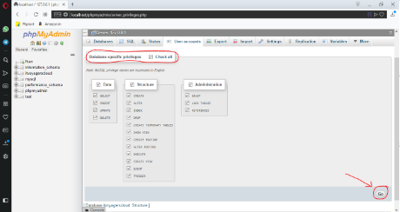

You can see that our user is been added.

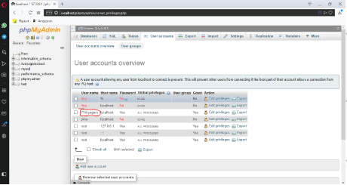

1. Now go to browser and enter <http://localhost/owncloud/> in URL bar.

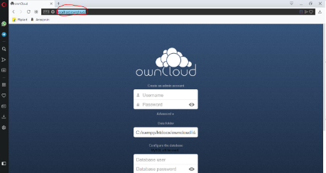

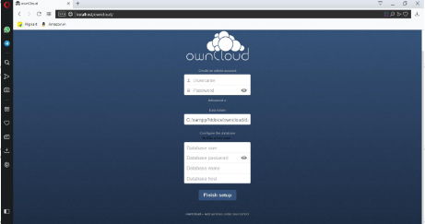

Above screen will be displayed.

1. Now we have to enter User name and Password for admin. And other credentials for the user which we just created, and click on “Finish setup”.

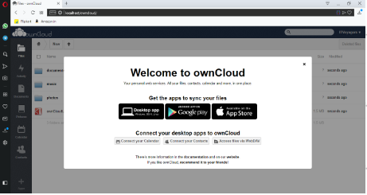

We have done it, we have installed OwnCloud ON XAMPP Server.

1. Go to “localhost/phpmyadmin” you can see that our database is been filled with tables.

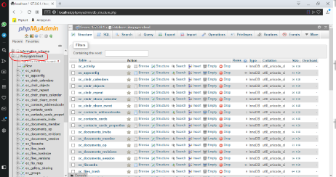

**PRACTICAL NO - 5**

**Study and implementation of identity management**

1. Click on link below.

<https://aws.amazon.com/console/>

go to “My Account” > “AWS Management Console”.

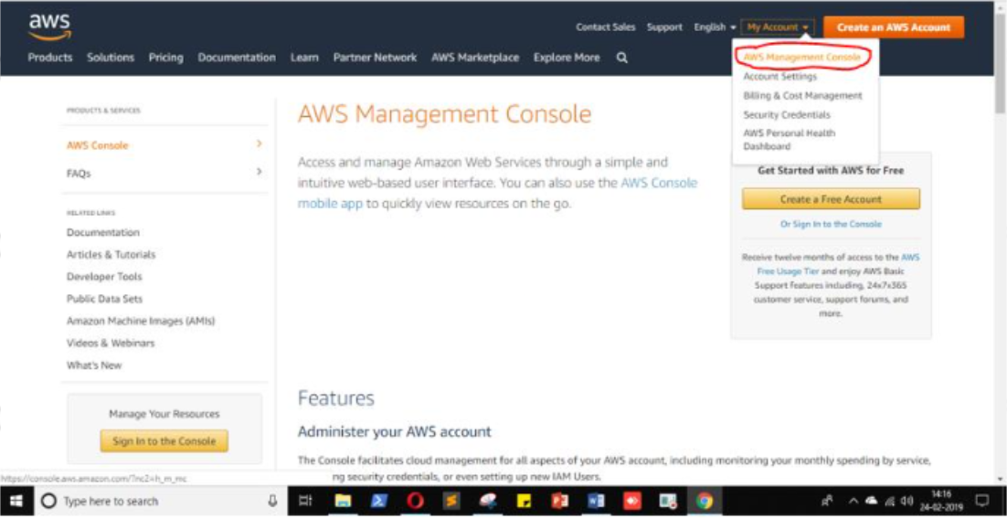

Click on “Create a new AWS Account “

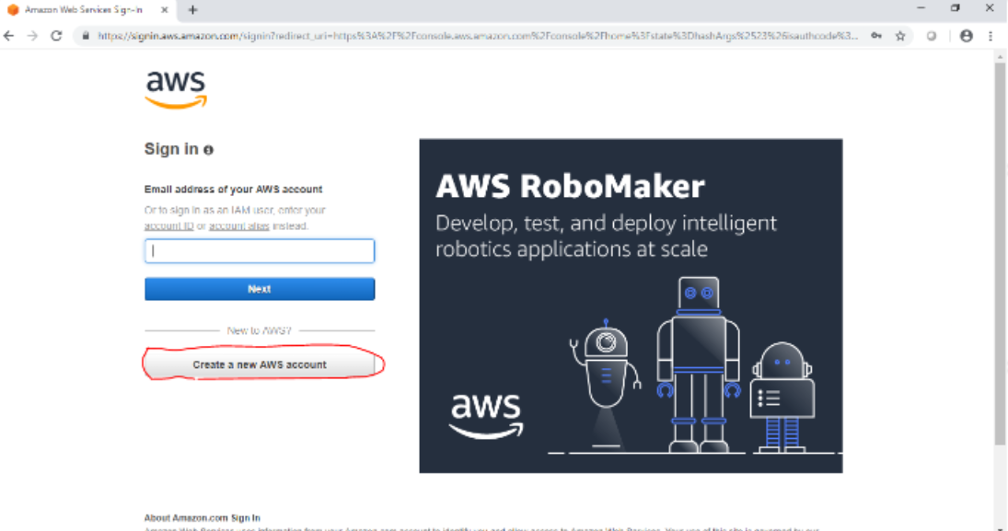

Fill the form & click “Continue”

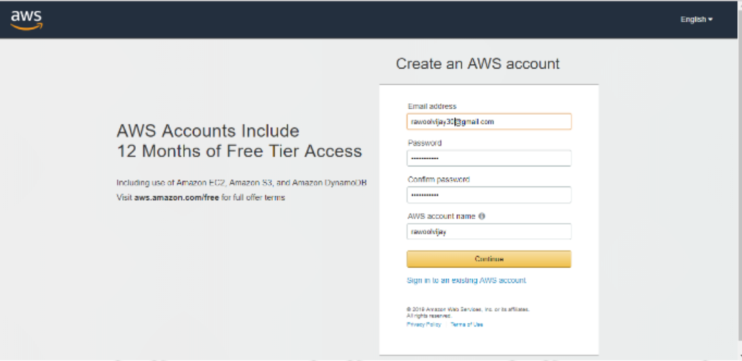

Fill other details and click on “Create Account and continue”

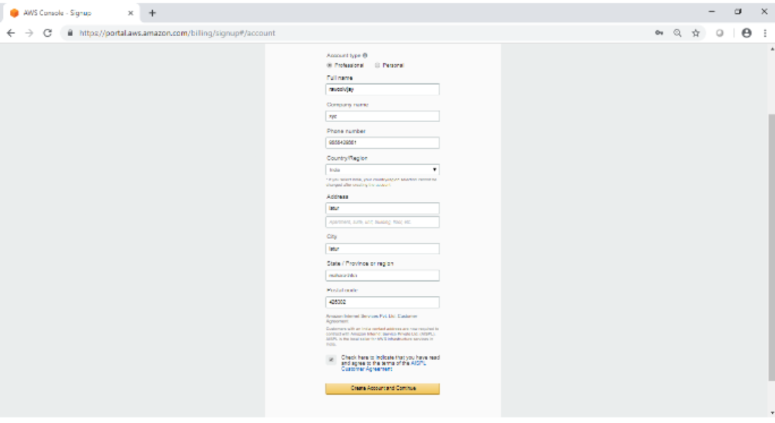

Now most curtail step aws will ask for credit card details and other details

You have to close the browser

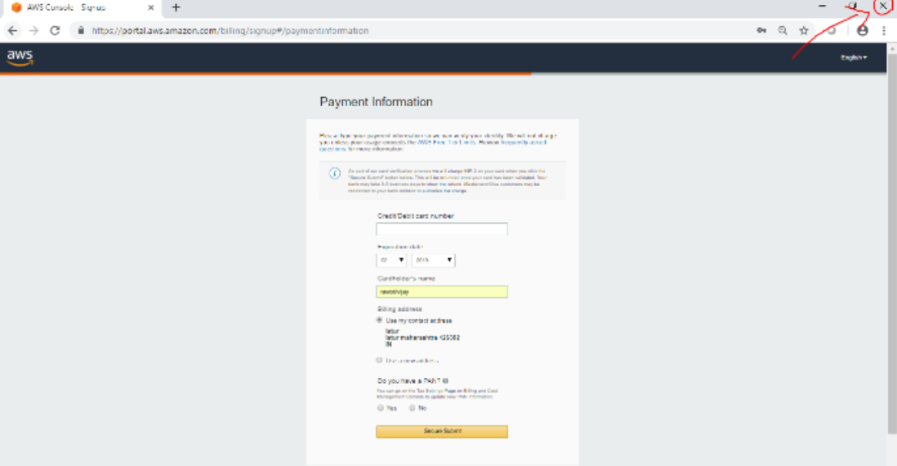

Now again navigate to link below

<https://aws.amazon.com/console/>

go to “My Account” > “AWS management console”

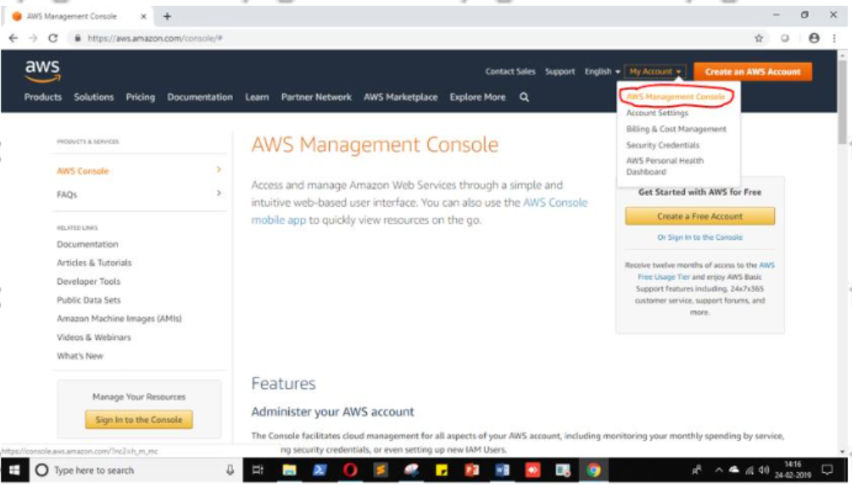

Enter your ID and click on “Next”

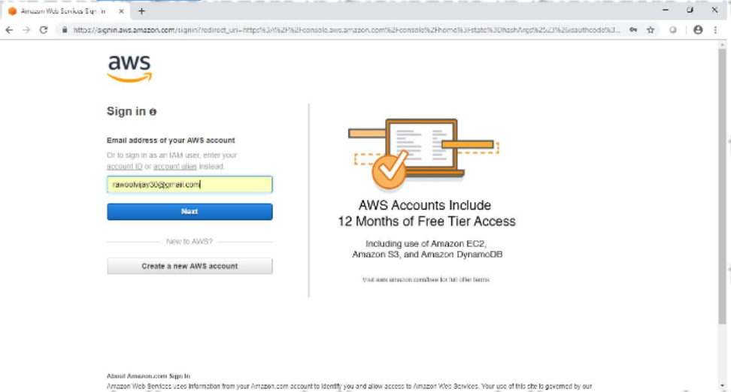

Enter your password and click on “Sign in”

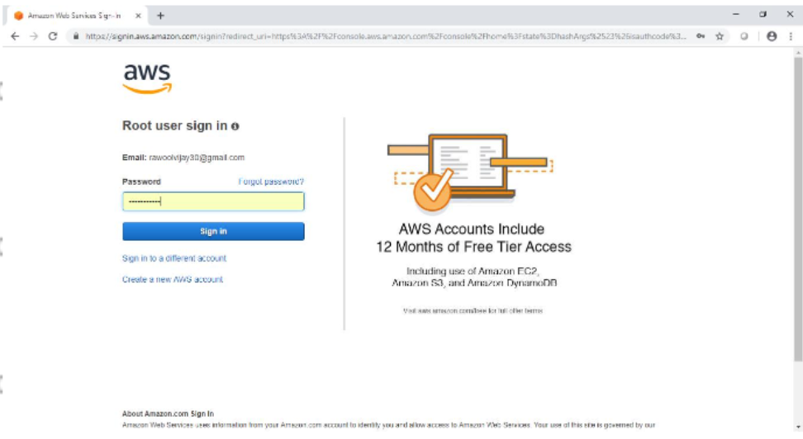

Now it will redirect you to home page without asking any other details. Now to we have to add user and group and assign them privileges

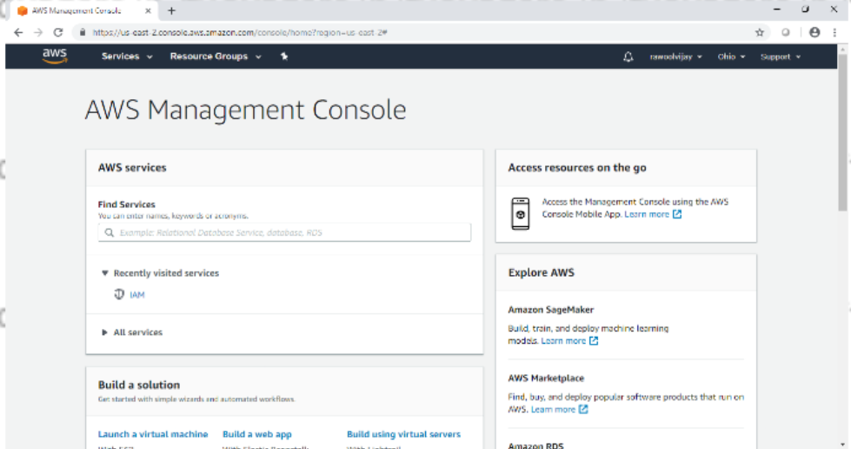

Go to “My security Credentials”

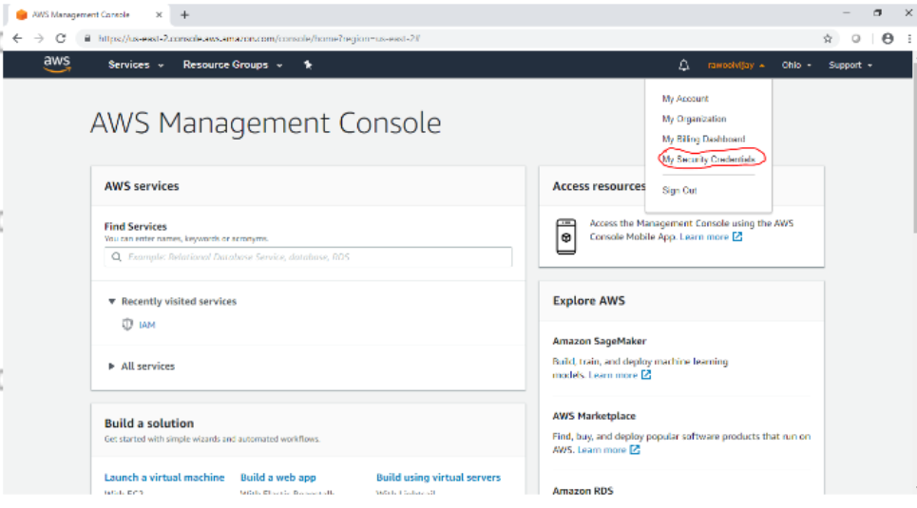

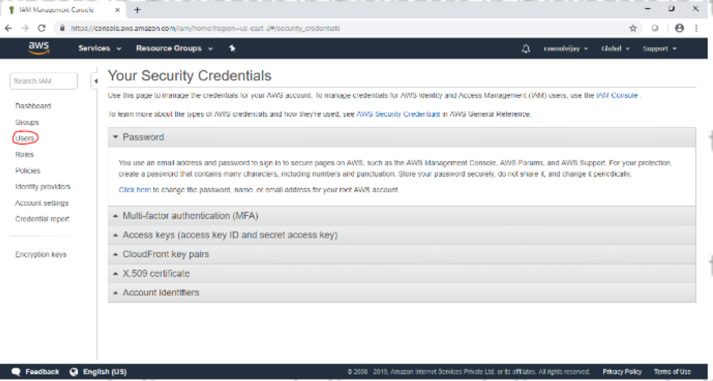

Click on users

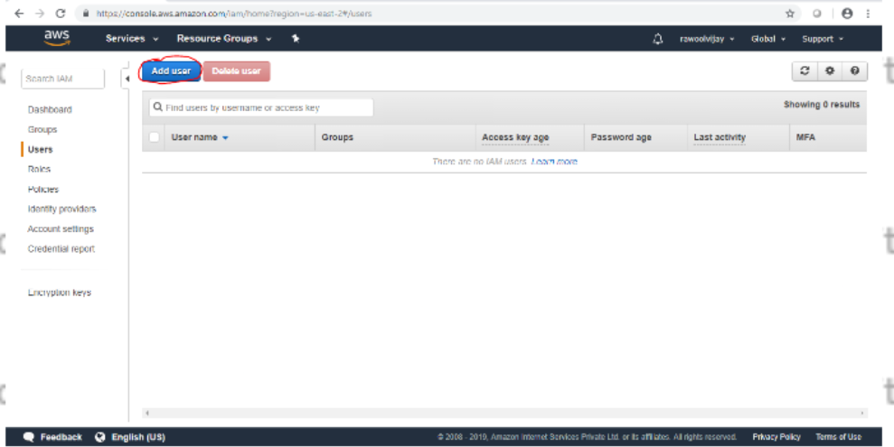

Click on Add user

Enter the name for the user. Check the check box in front of “Programmatic acccess” and AWS Management console access

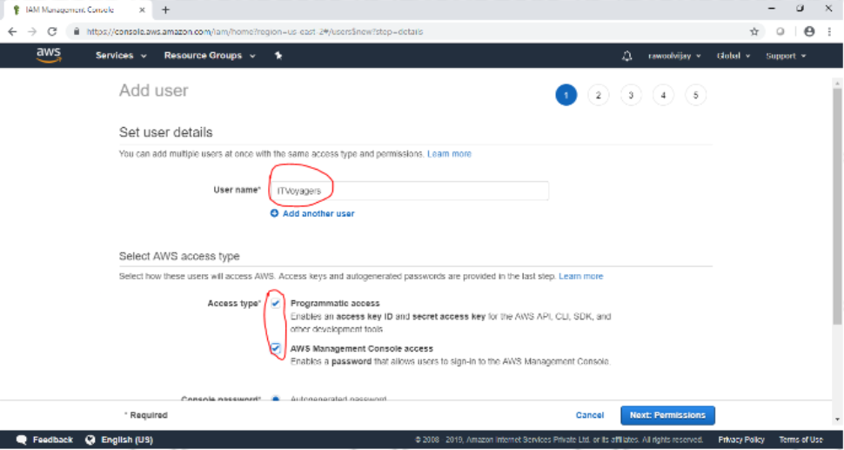

Scroll down and select “Custom password” and enter the password for the new user and click on “New permission”

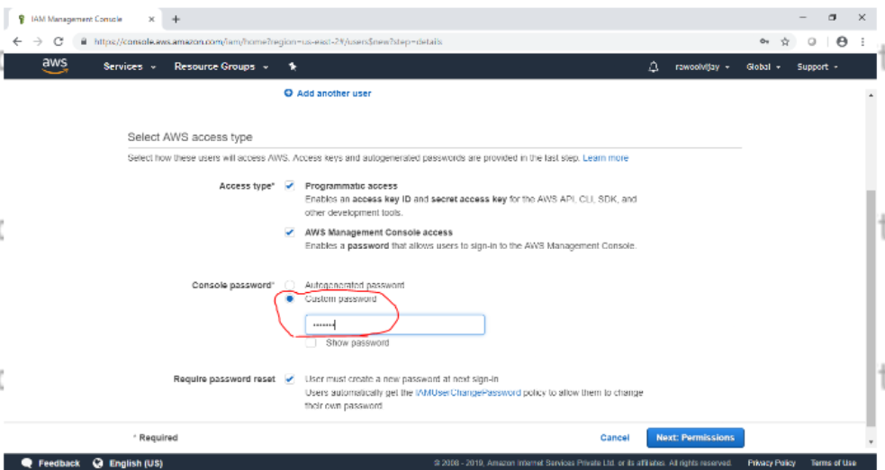

Next it allow you to create group or you can just pass it. We are going to create group and click on “Create group”

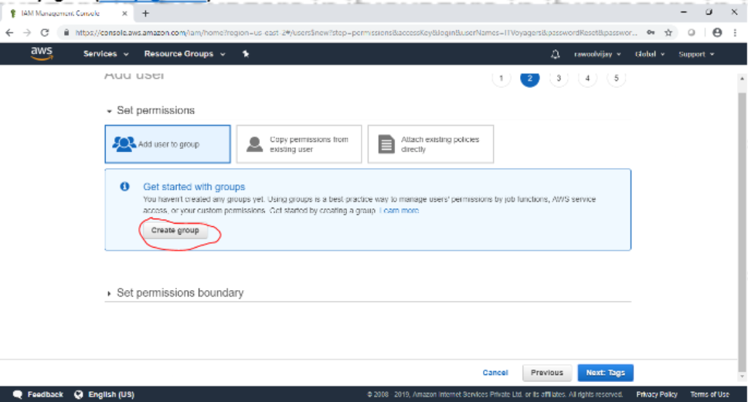

Following window will appear

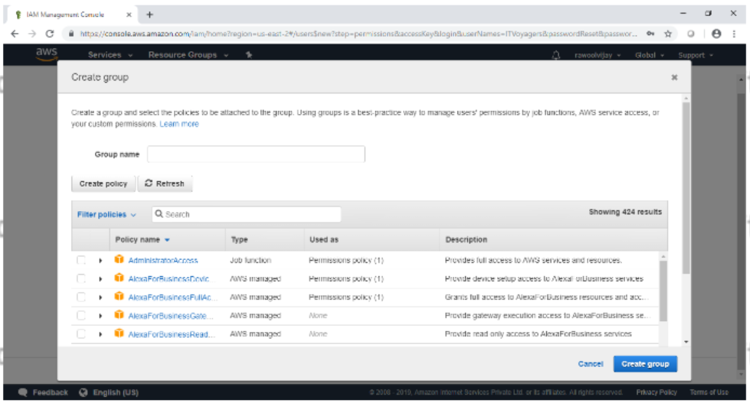

Give name to group, assign the their permission and click “Create group”

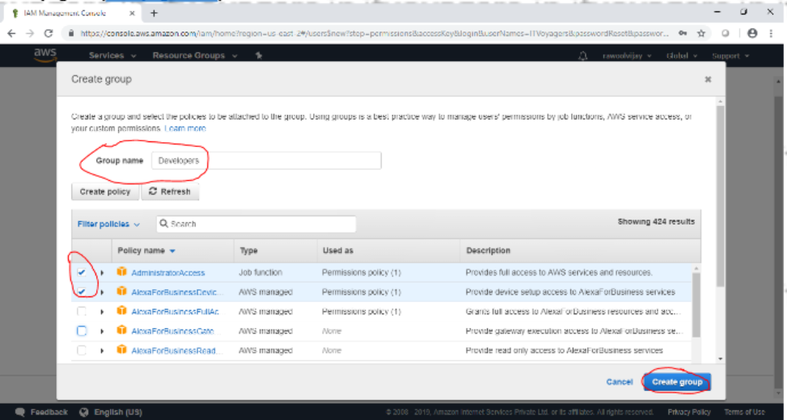

Your group is created now click on “Next tags”

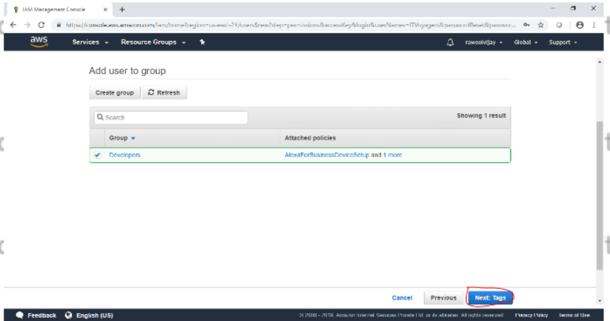

Click on new review

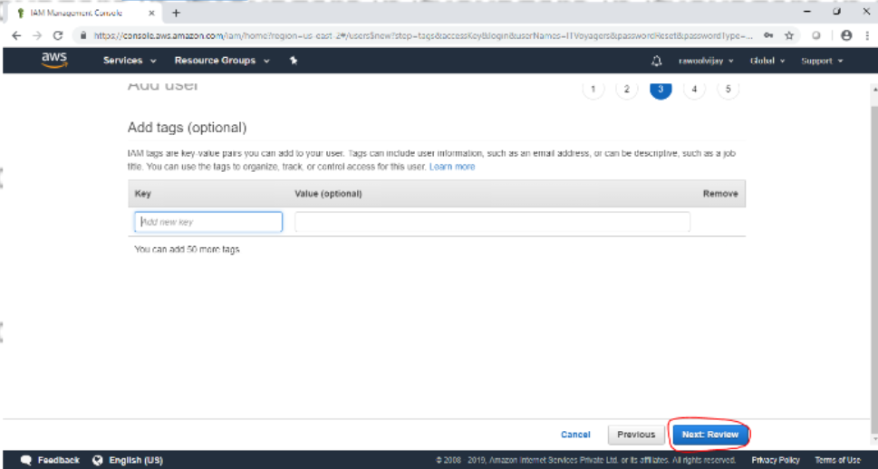

Click the review for the user and click on create user

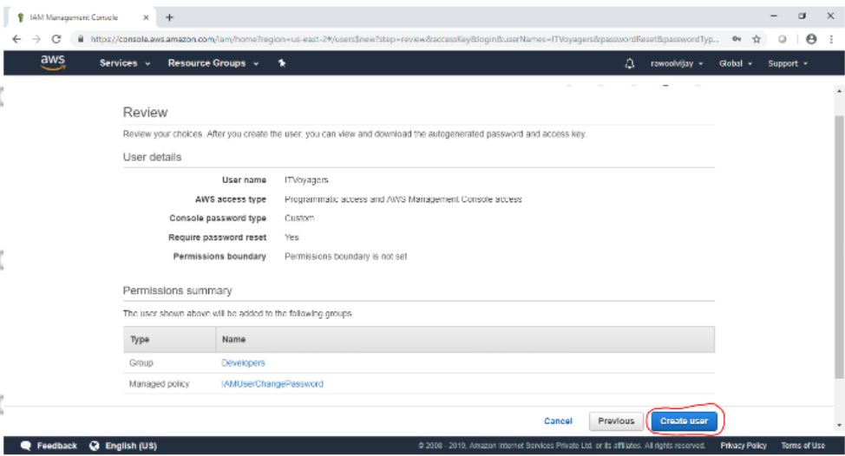

Click on close

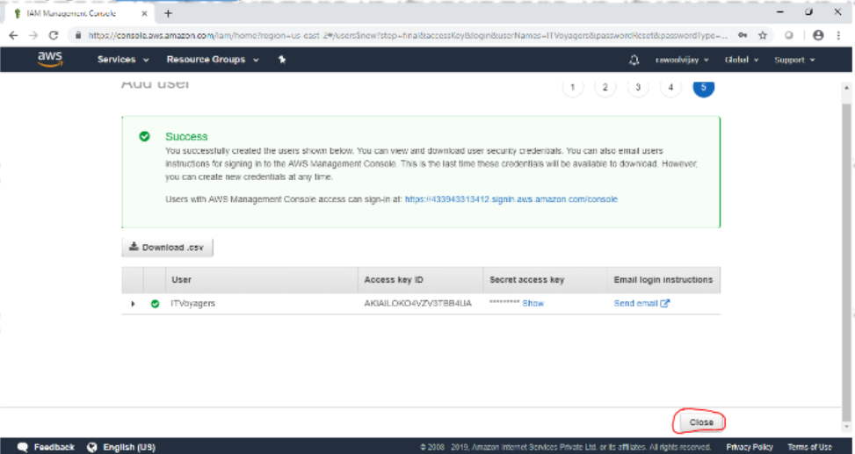

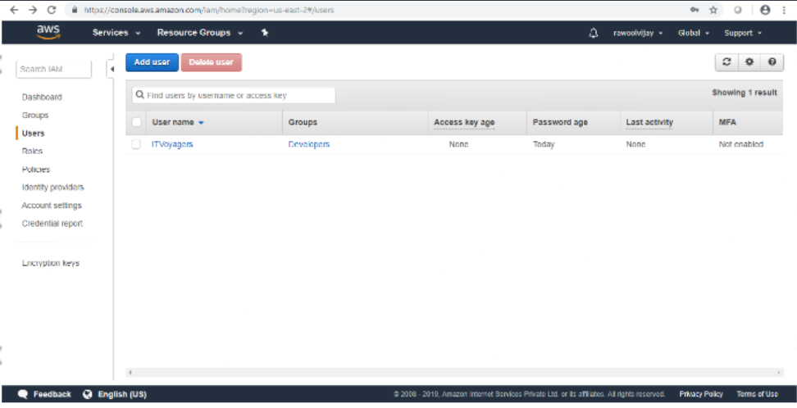

Click on group you will see the group you just created.

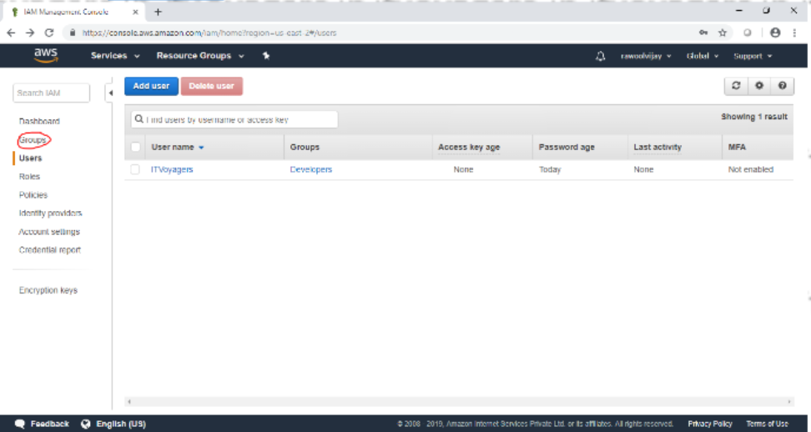

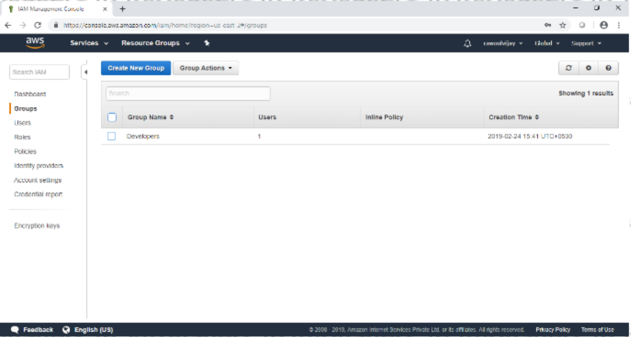

Now log out of admin account and try to login as user (newly created)

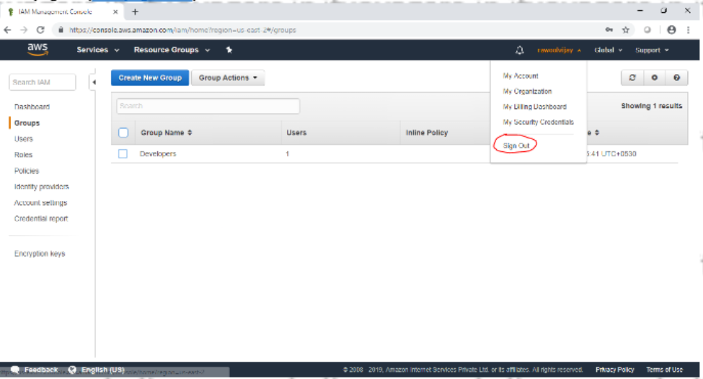

Navigate to link below

<https://aws.amazon.com/console/>

Go to my account > aws management console

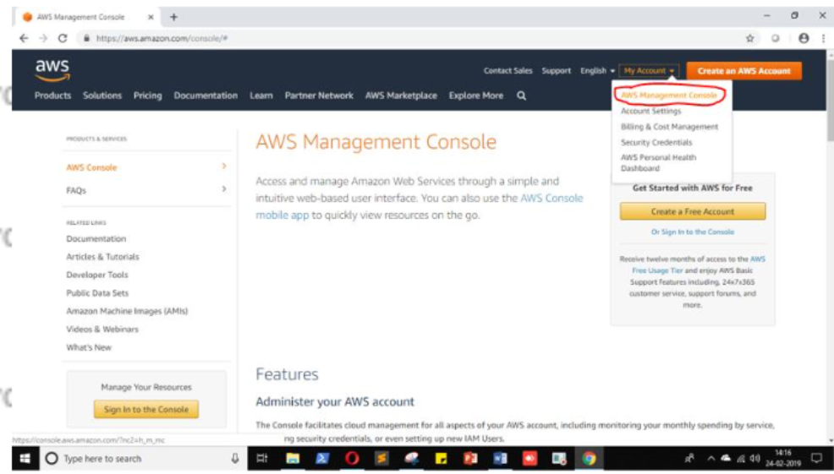

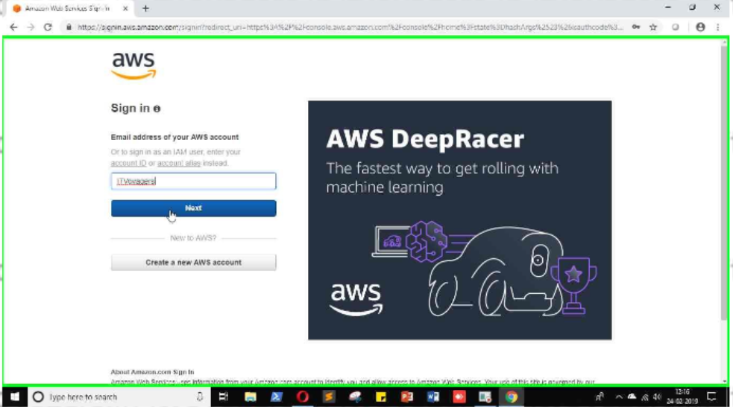

Just login to your users account

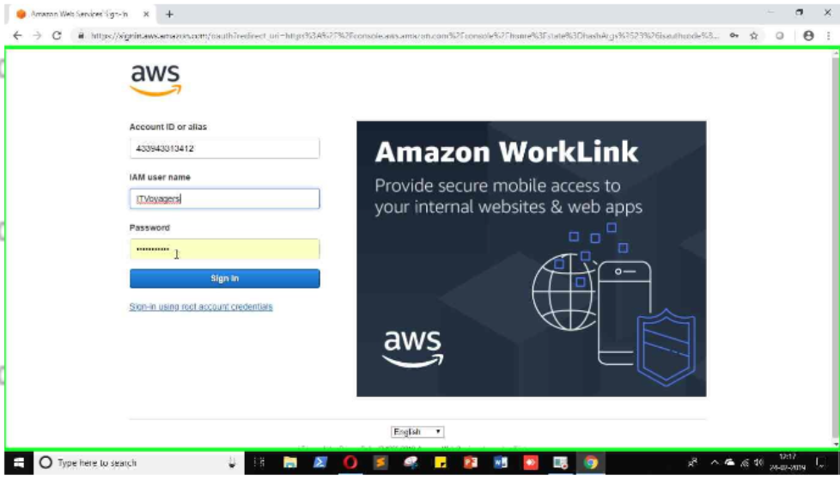

It will ask you to change the password which is been set by administrator

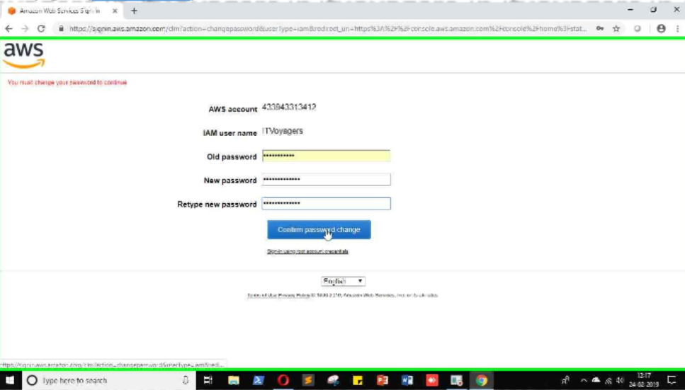

You will be redirected to home screen

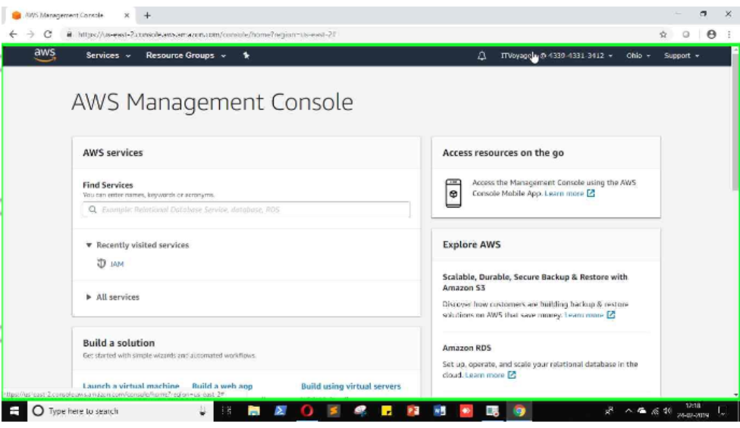

**PRACTICAL NO - 6**

**Study Cloud Security management**

1. Click on link below.

https://aws.amazon.com/console/

Go to “My Account”>”AWS Management Console”

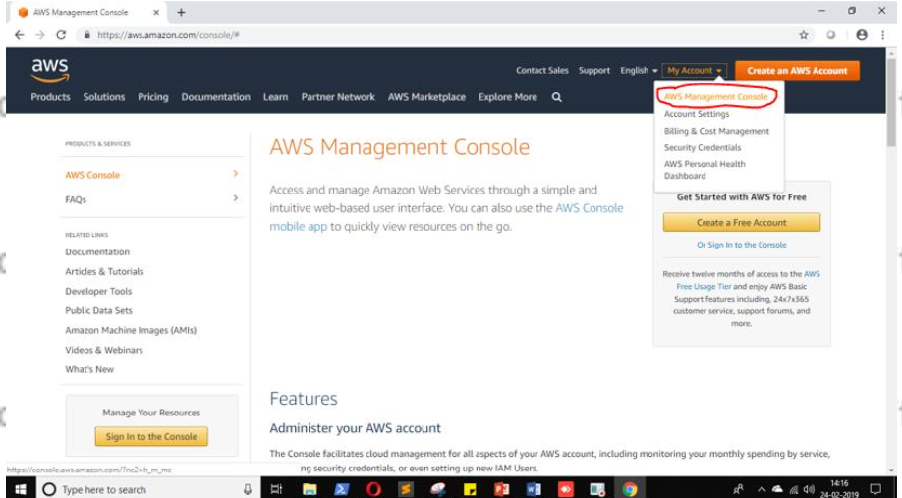

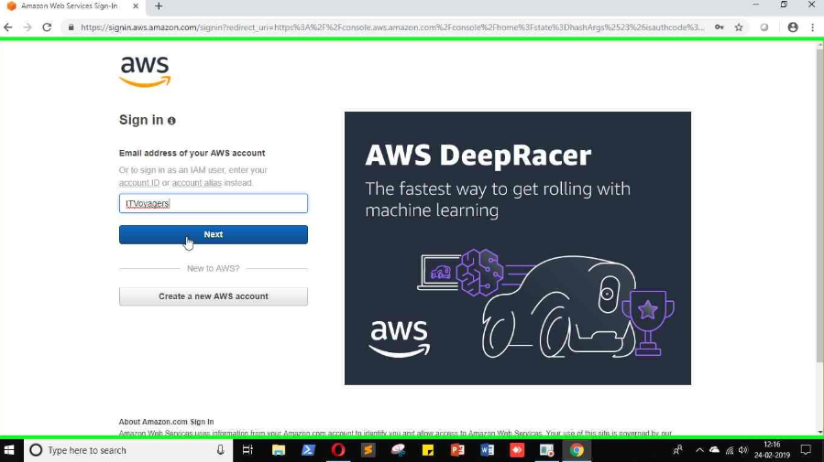

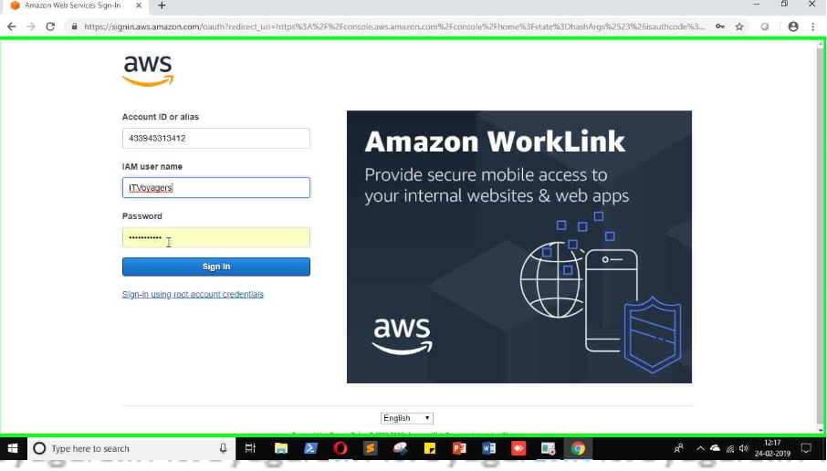

2.just login to your users account.

3.click on “sign in”

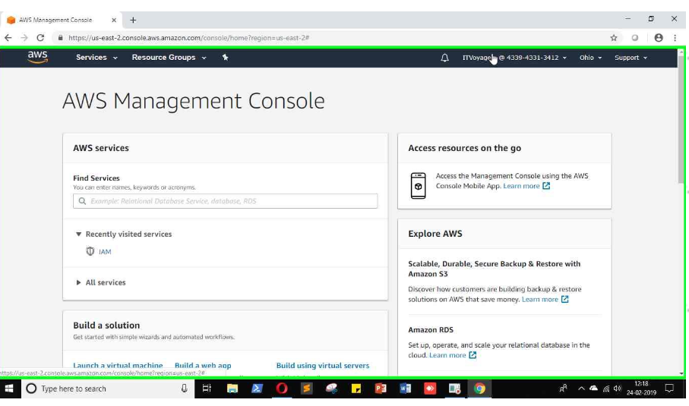

4.Once you logged in go to “My Securiy Credentials”

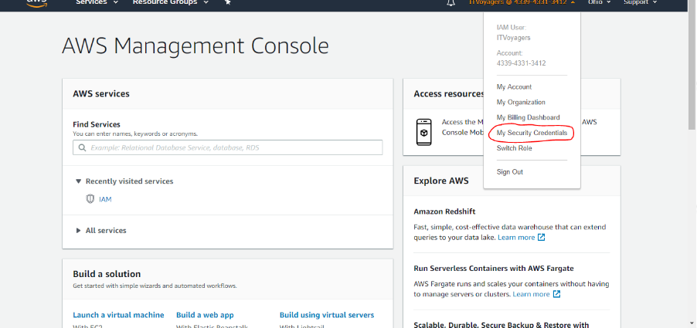

5.Scroll down you will find “Multi-factor authentication(MFA)”

Click on “Assign MFA device”

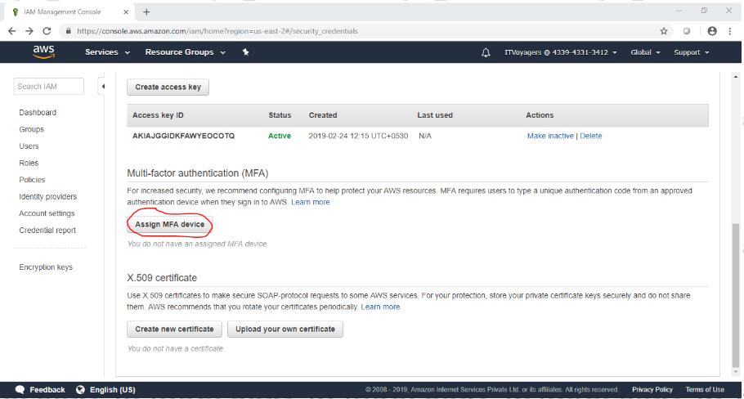

6.we will select first option”virtual MFA device” click on”Continue”

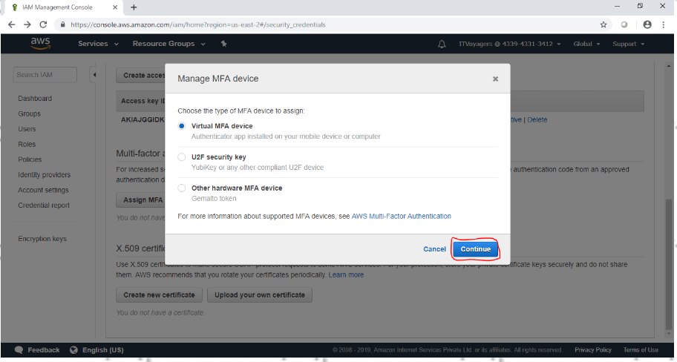

7.so concept is we will use third party app to generate OTP which will help use to authenticate ourselves during logging in.it will add a security layer to our account.

Now we have to download “2FA Authenticatore(2FAS)” app on our mobile.

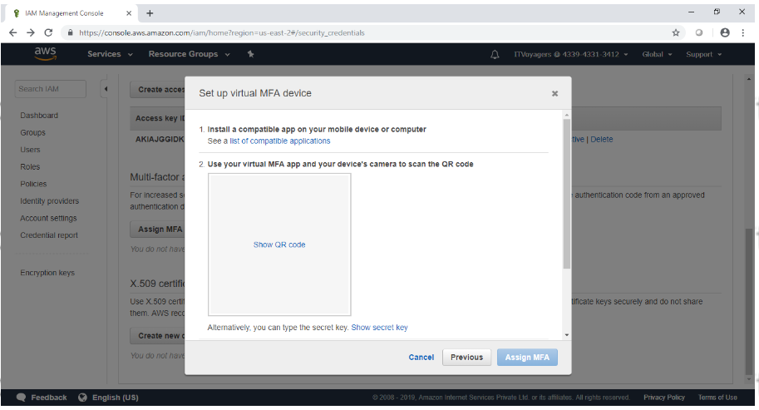

8.click on “Show QR code” to display QR code.

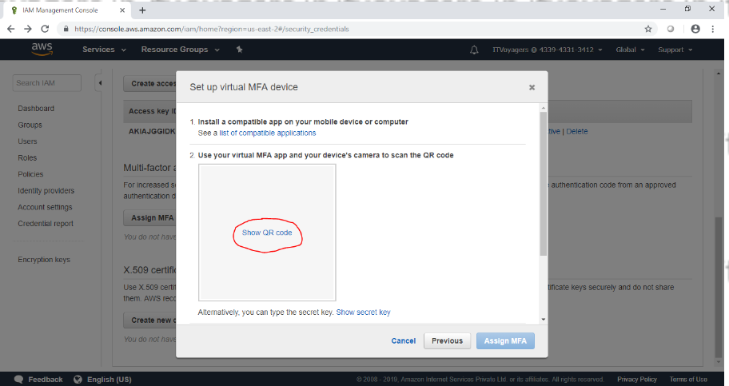

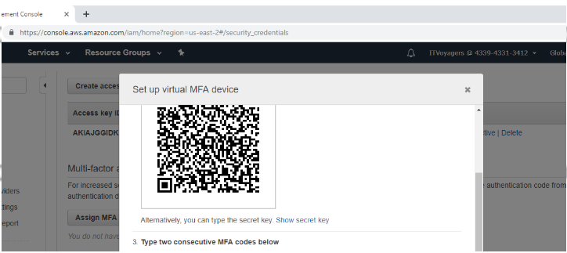

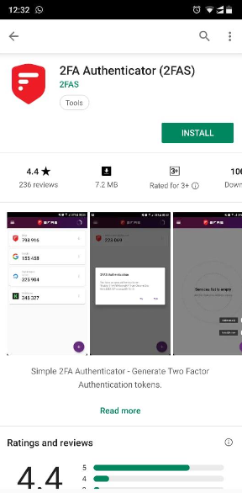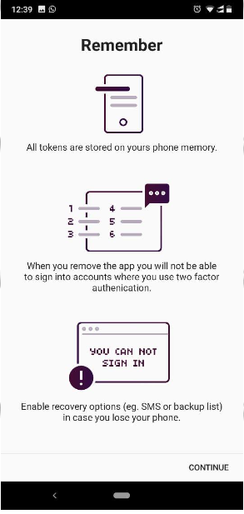

9.now click on + and click on “Scan QR code”

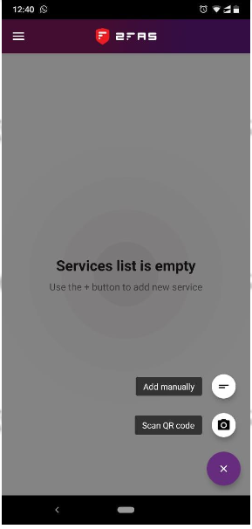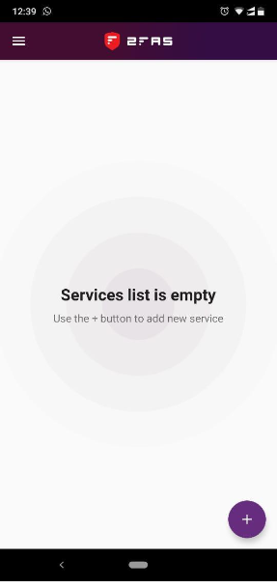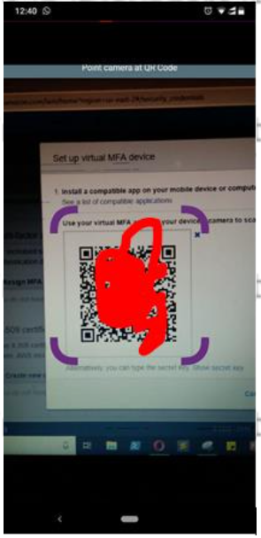

10.first we have to enter 2 OTP which we will receive on app and click “Assign MFA”

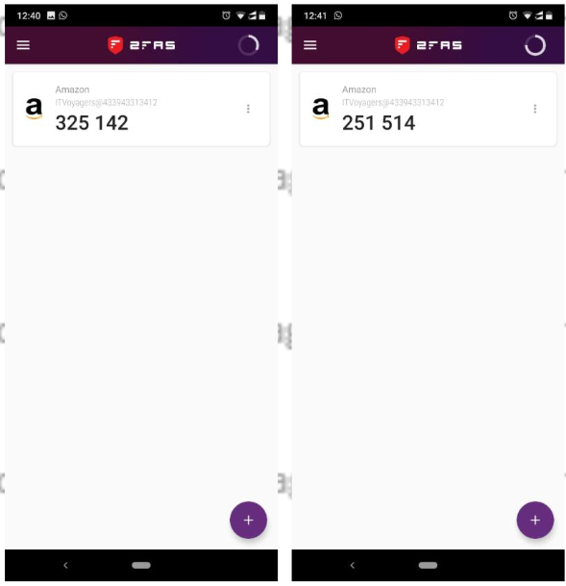

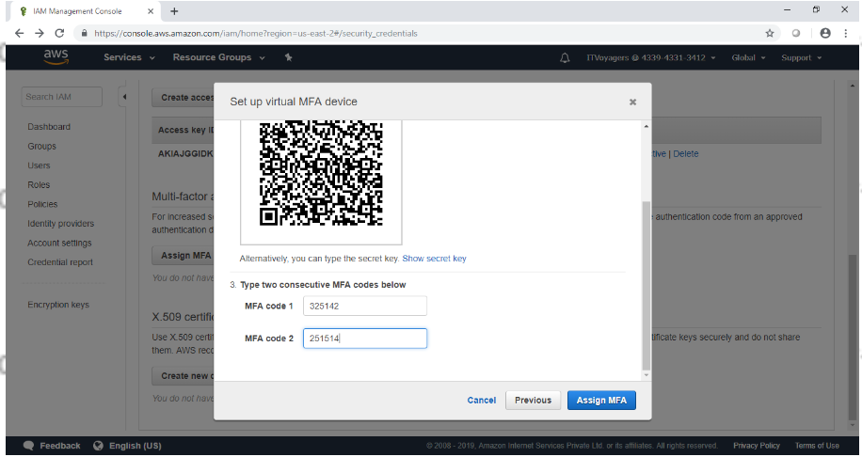

11.click on “close”

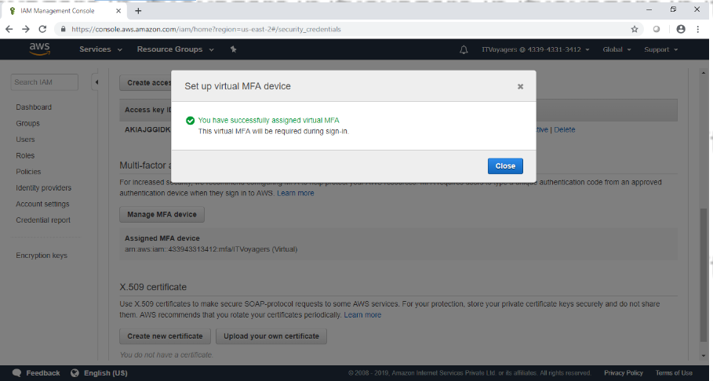

12log out from the account.

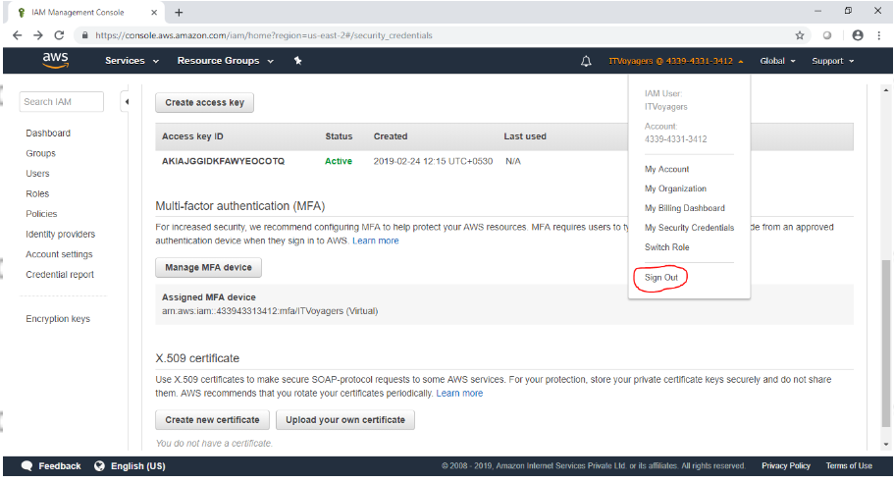

13.now again try to log in to your account.

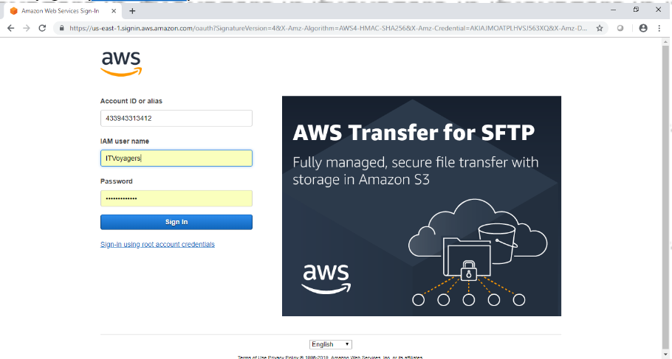

14.it will ask for MFA code .you will get new code after every 30 secends,just enter the valid MFA code and click on “submit”

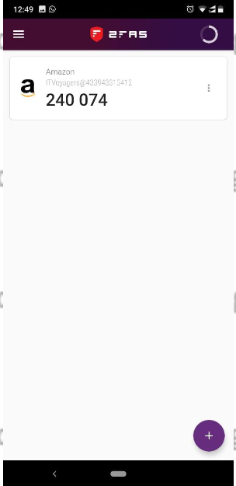

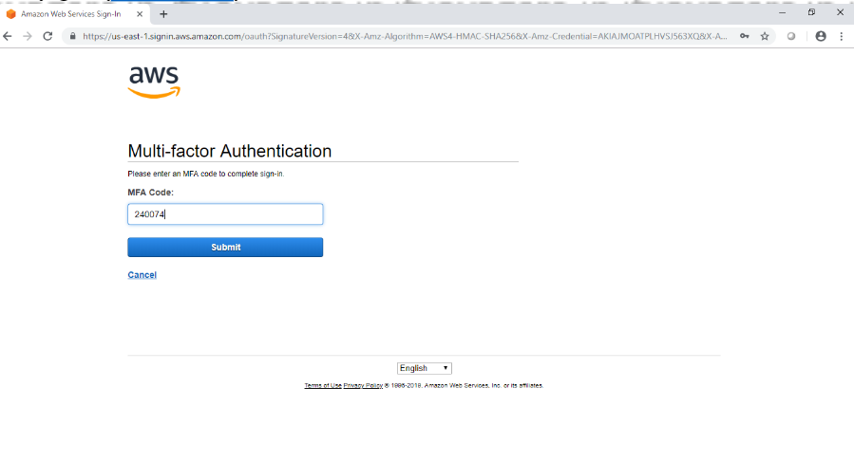

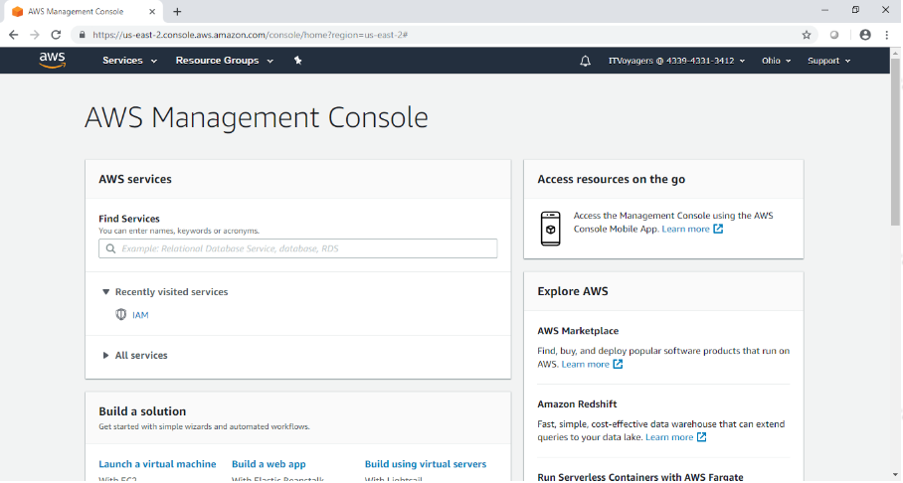

**PRACTICAL NO - 7**

**Write a program for web feed.**

1.we are using XAMPP.first open notepad and write the following XML code in it.

<?xml version="1.0" encoding="UTF-8" ?>  
<rss version="2.0">  
<channel>  
<item>  
 <title>ITVoyagers</title>  
 <link>[https://itvoyagers.in/</link&gt](https://itvoyagers.in/%3C/link&gt);  
 <description>ITVoyagers is an educational blog for information technology and computer science program.We have started this  
blog with a goal of meeting the requirements of learners to cope with the changing technology.  
We are aiming to expand its scope in all sections of IT.</description>  
</item>  
 <item>  
 <title>Cloud Computing</title>  
 <link>[https://itvoyagers.in/cloud-computing/</link&gt](https://itvoyagers.in/cloud-computing/%3C/link&gt);  
 <description>Cloud Computing Blog</description>  
 </item>  
 <item>  
 <title>BI</title>  
 <link>[https://itvoyagers.in/advance-topics/business-intelligence/</link&gt](https://itvoyagers.in/advance-topics/business-intelligence/%3C/link&gt);  
 <description>Business intelligence blog</description>  
 </item>  
 <item>  
 <title>wikipedia</title>  
 <link>[https://www.wikipedia.org/</link&gt](https://www.wikipedia.org/%3C/link&gt);  
 <description>work from home</description>  
 </item>  
</channel>  
</rss>

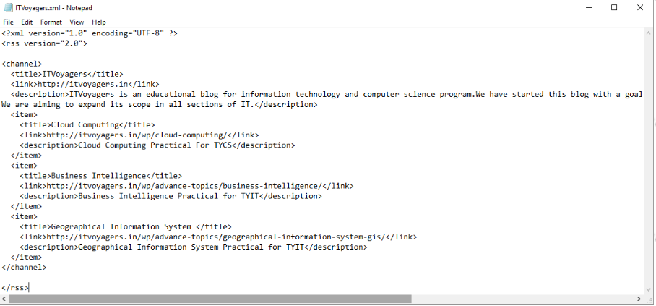

2.save the as “ITVoyegers.xml”file in “C:\xampp\htdocs\RSS” directory(you can change the file name but save the file in “.xml” format. Now start “Apache” server from”XAMPP Control Panel”.

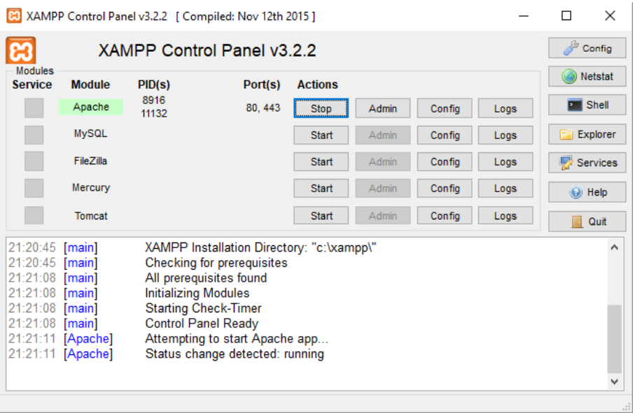

3.Open google chrome and enter<https://localhost/RSS/ITVoyegers.xml>in URL bar.then add RSS subscribtion extension.

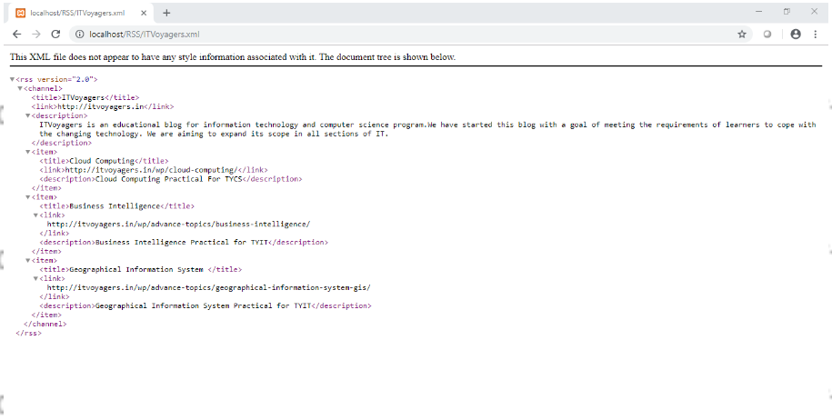

4.to add extension go to the following link

<https://chrome.google.com/webstore/detail/rss-subscibtion-extension/nlbjncdgjeocebhnmkbbbdekmmmcbfjd?hl=en>

click on “Add to chrome”.

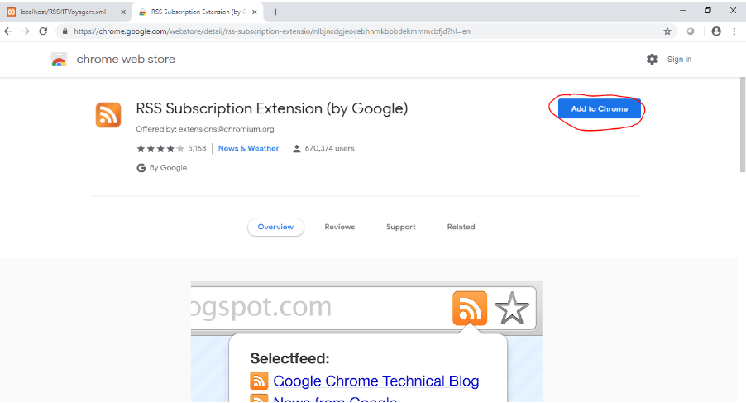

5.pop-up will show up click on “Add extension”.

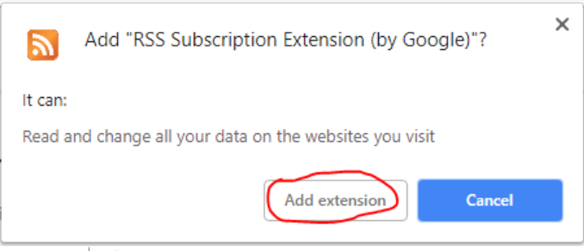

6.Now just refresh your page.

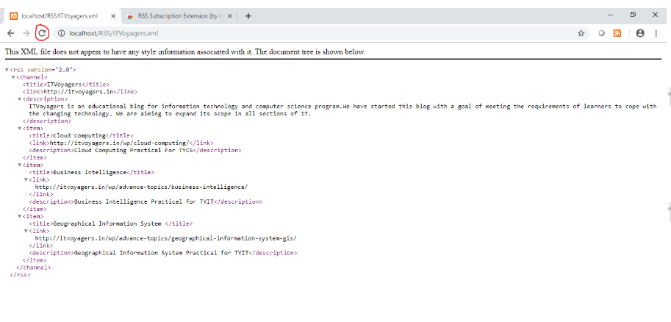

7.your output will get load.

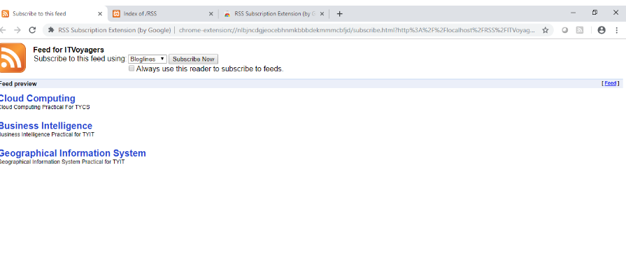

8.click on any link to check if it is working.

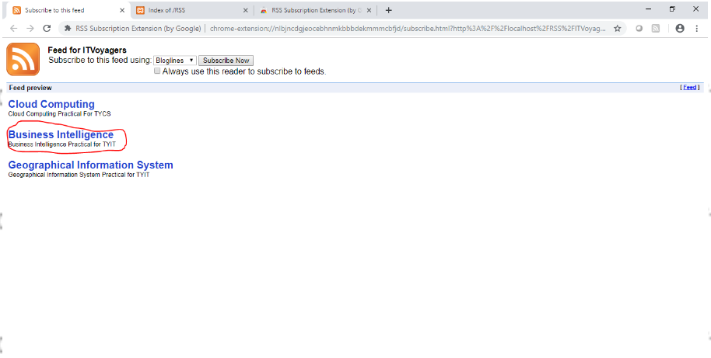

9.if it redirects you to the respective page then your is over.

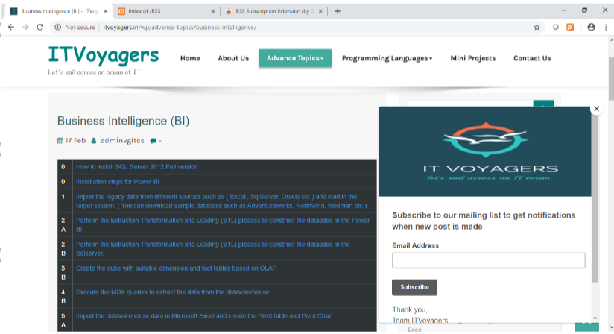

**PRACTICAL NO -8**

**Study and implementation of Single-Sing-On.**

1.Go to following link

[https://auth0.com/learn/how -to-implement-single-sign-on/](https://auth0.com/learn/how%20-to-implement-single-sign-on/)

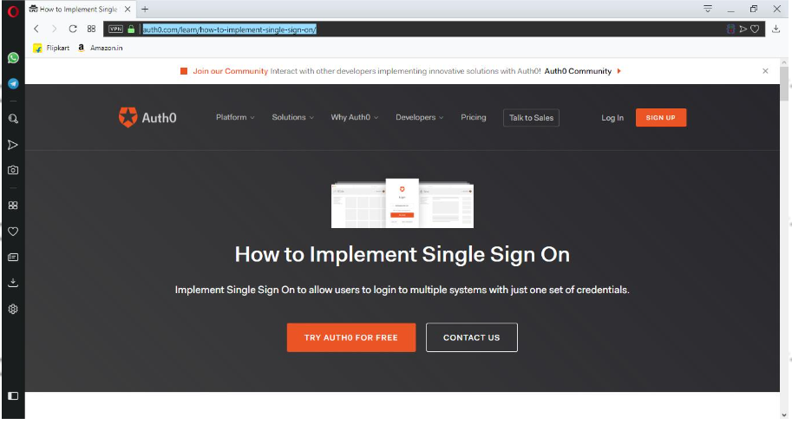

2.click on “TRY AUTH0 FOE FREE”.

3.Enter ID and Password for your account and click on ok”SIGN UP”

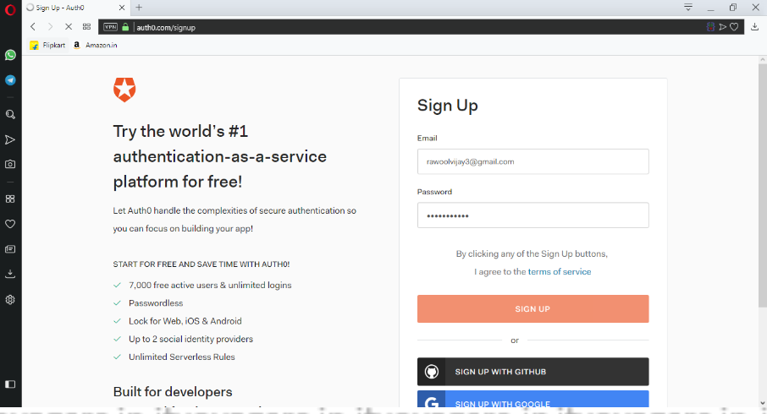

4.Now enter “TENANT DOMAIN” and select “REGION’ for your account and click on “NEXT”

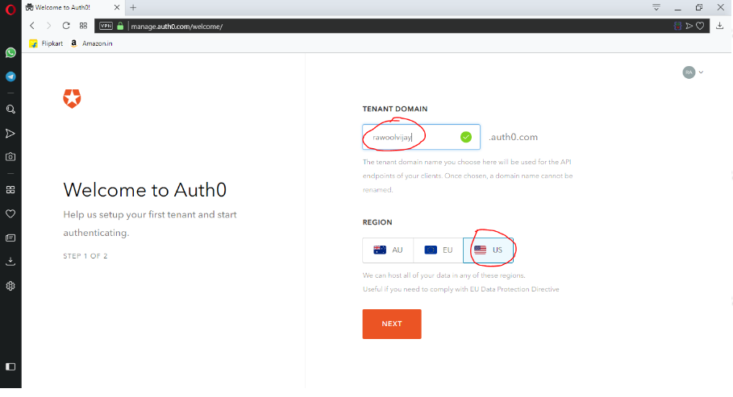

5.in”ACCOUNT TYPE” panel select “Personal” then

Select “non developer” in “ROLE”

And “just playing around” in “PROJECT”panel and click on”CREATE ACCOUNT”

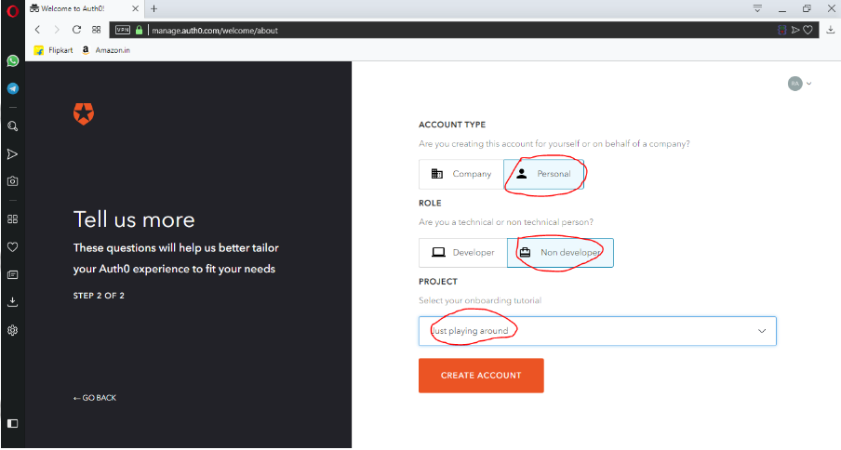

6.you will redirect to your “dashboard”

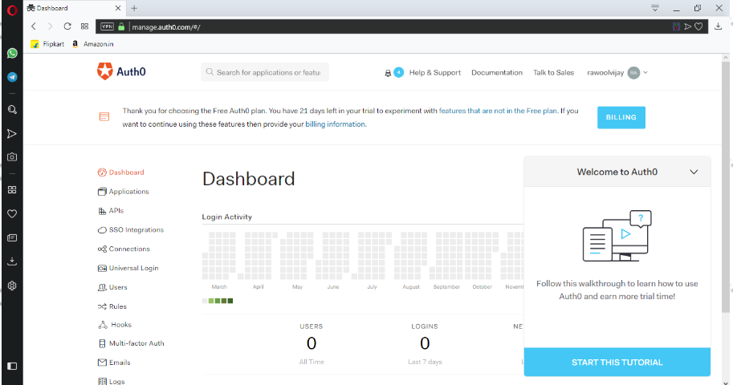

7.now go to “connection” > ”social”

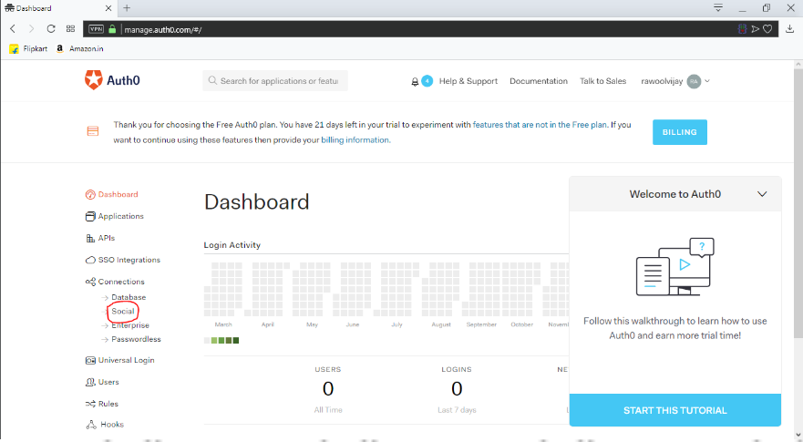

8.you will see many social accounts there we are going to try it with google.click on”TRY>” button

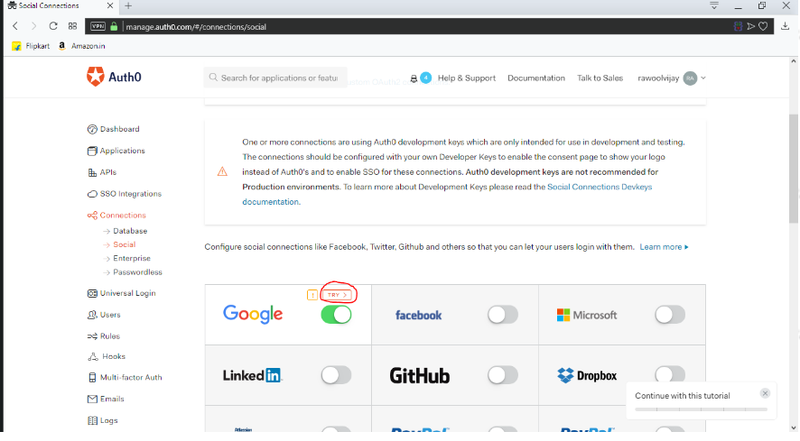

9.you will get redirected to google accounts

10.now enter your email Id and password and submit

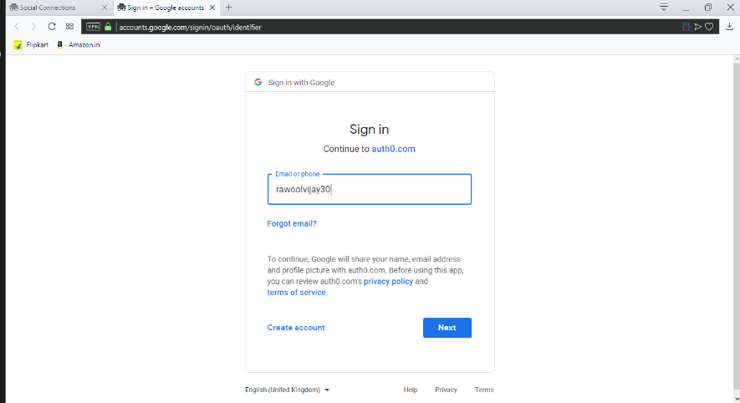

11.if you get the following window then your practical is completed successfully.

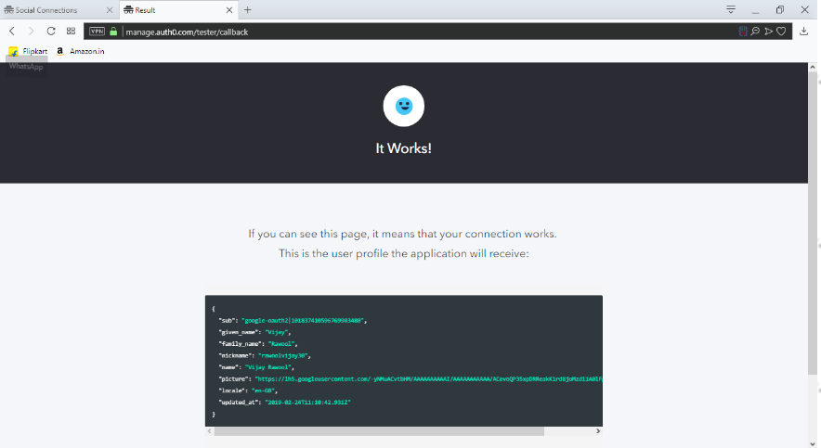

**PRACTICAL NO - 9**

**User Management in Cloud.**

1.first open XAMPP Control Panel and start “Apache and “MySQL” service.

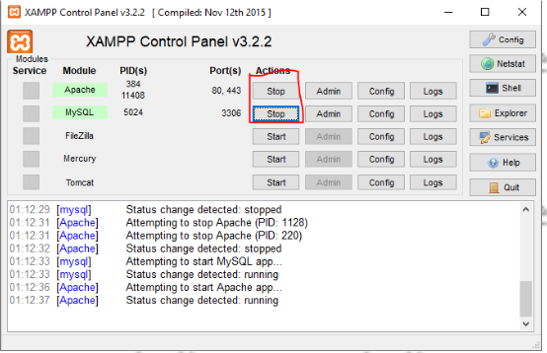

2.open browser and type “localhost/owncloud/” in URLbar and press “enter”.

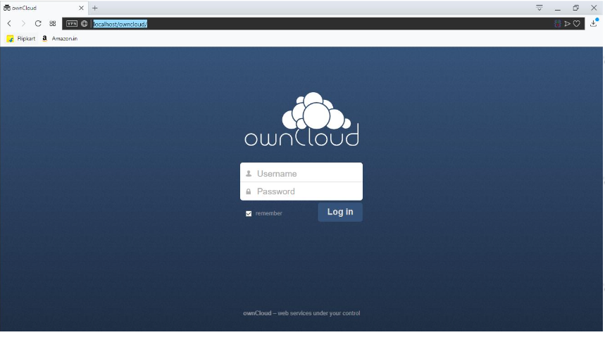

3.enter admin name and password which you have set while creating account and click on “log in”

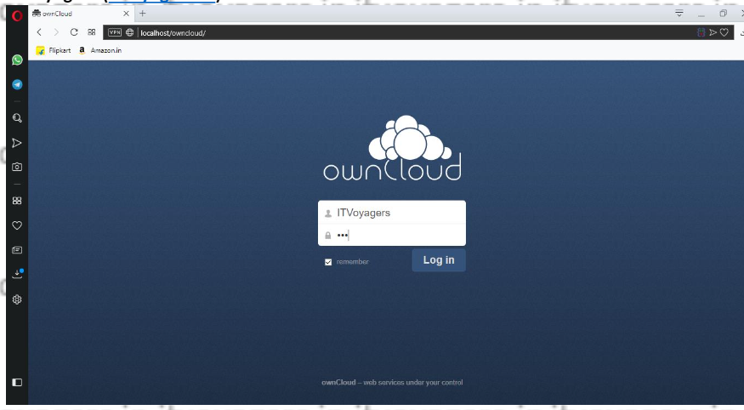

4.following dashboard will get load

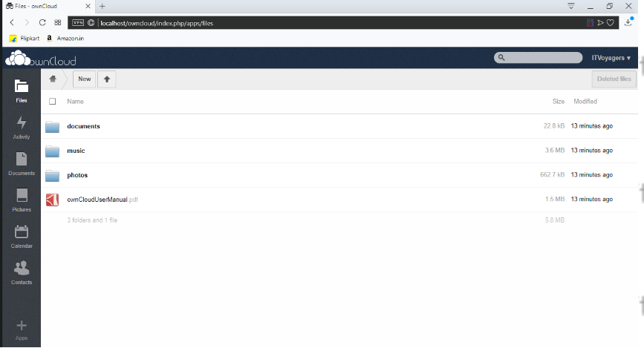

5.now go to “users”

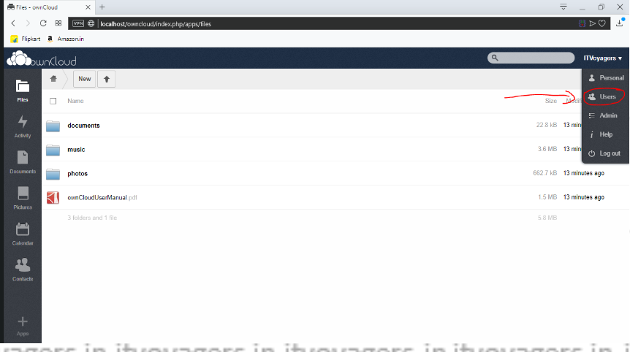

6.you can see that there is only user which is admin,which is in group admin

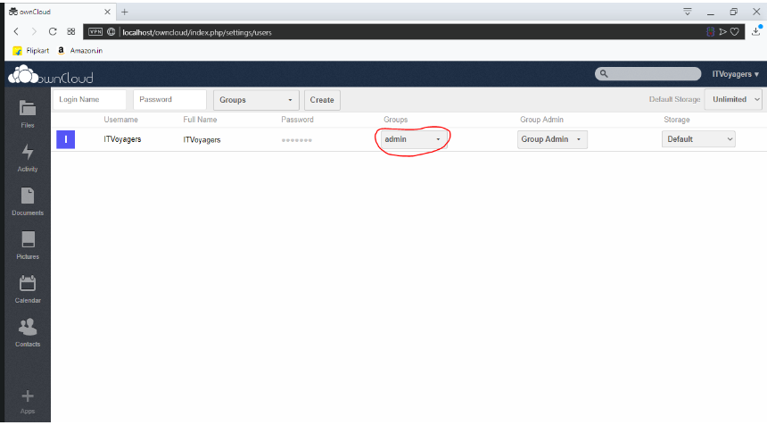

7.now lets add group,for that go to “group” > “add group”.

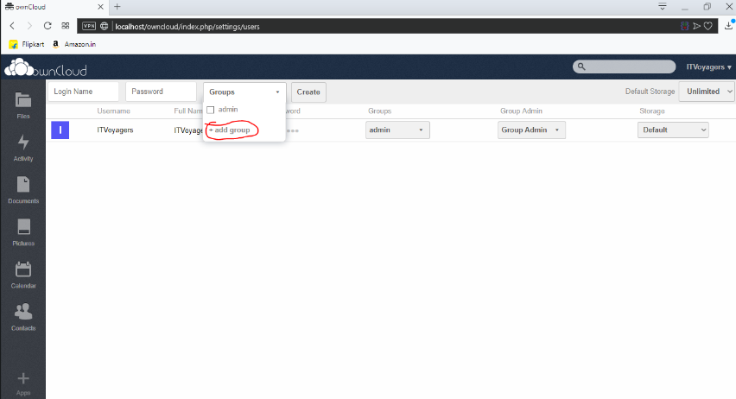

8.enter group name and press “enter”

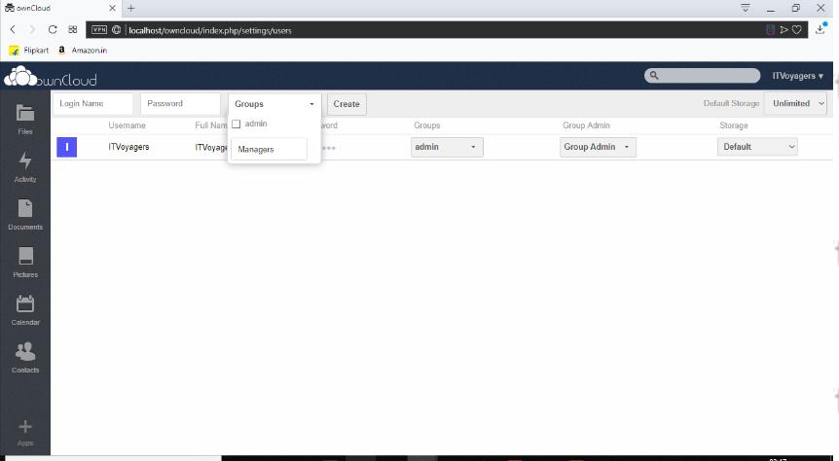

9.our group is been added,now select it.

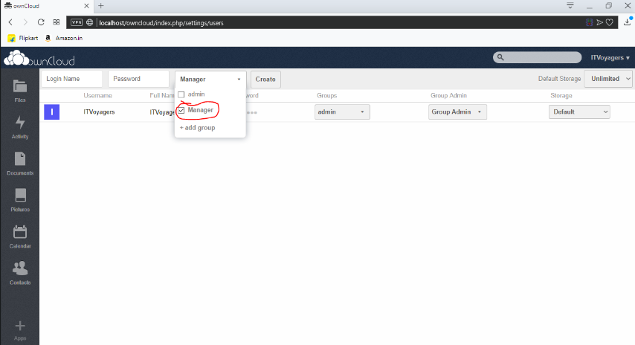

10.now enter “loginname” and “password” for the user and click on”create”

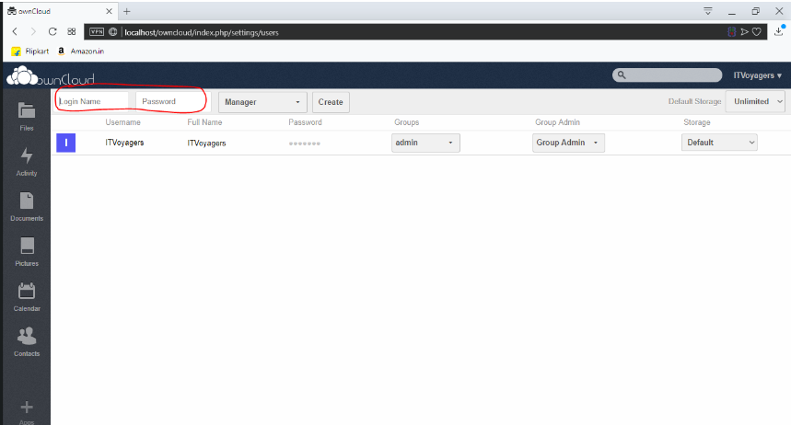

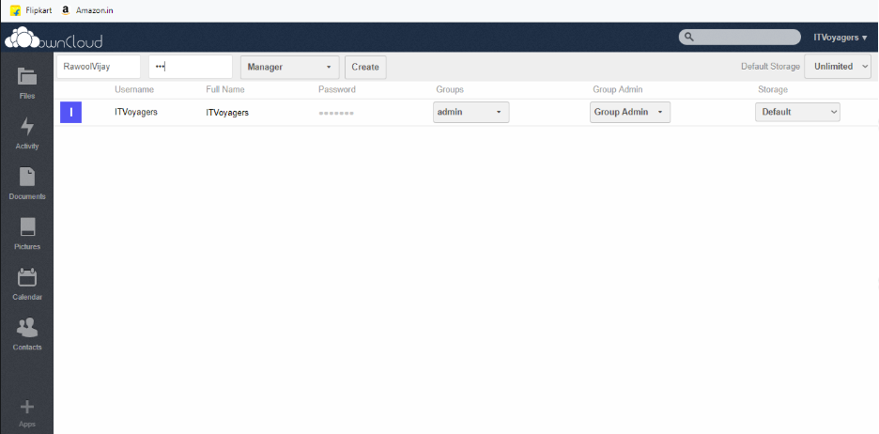

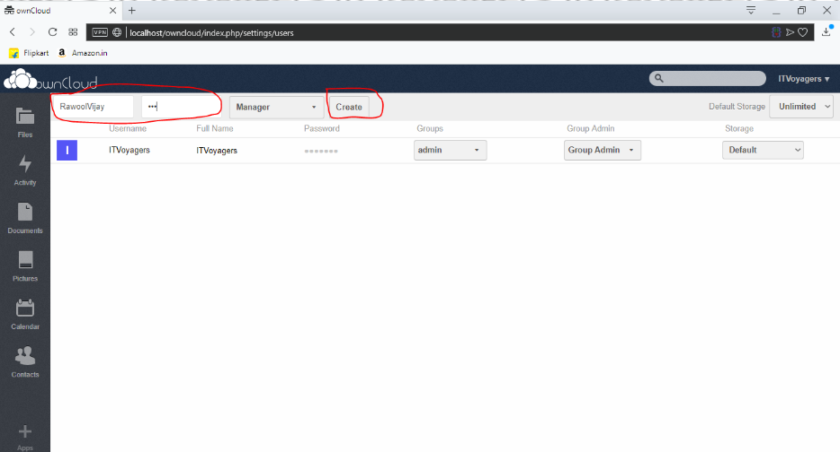

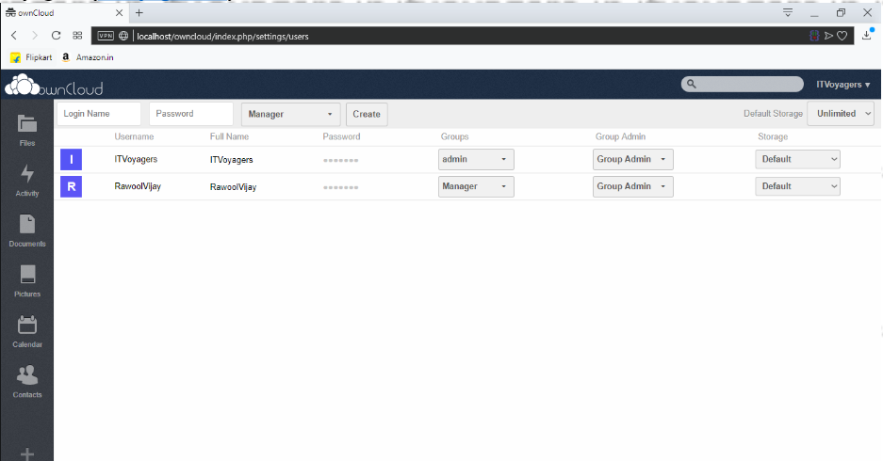

11.our user is been added we can change the storage limit for the new user.

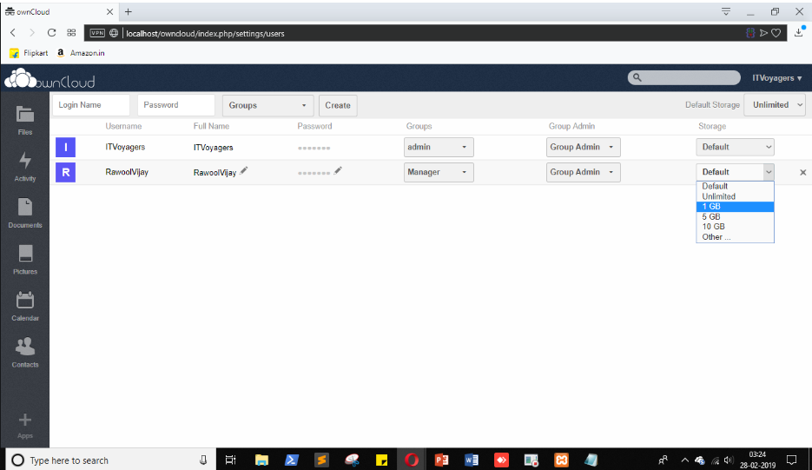

12.default limit is unlimited as mentioned above.

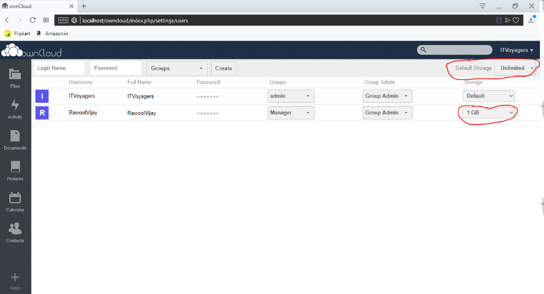

13.lets add another user but this time in”admin” group

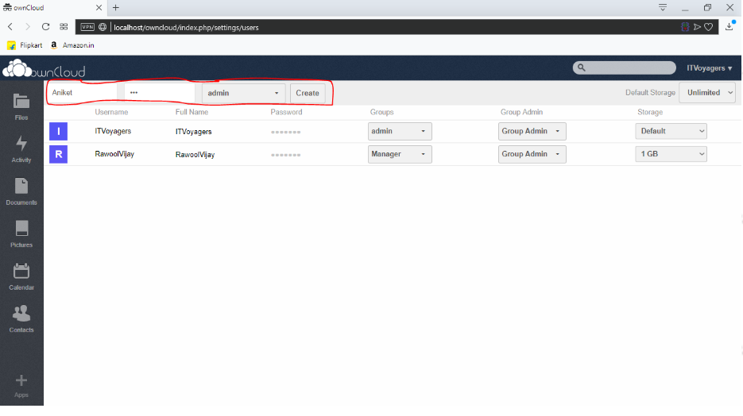

14.if it shows “admin,admin” in group just click on it and uncheck one “admin”

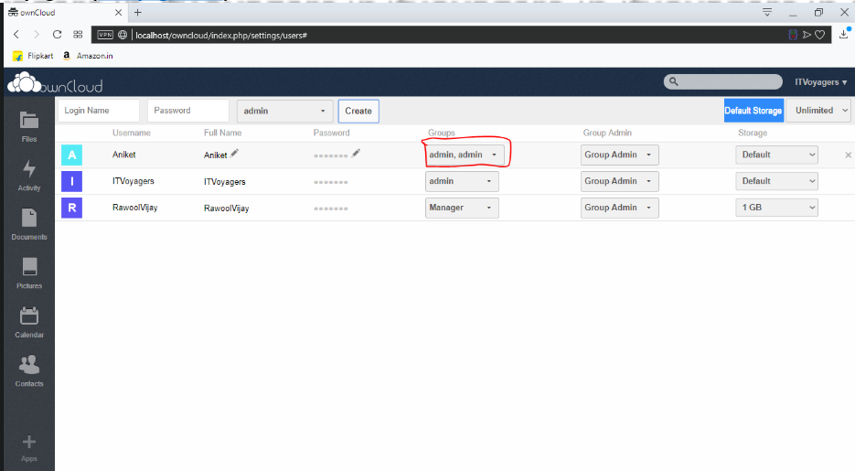

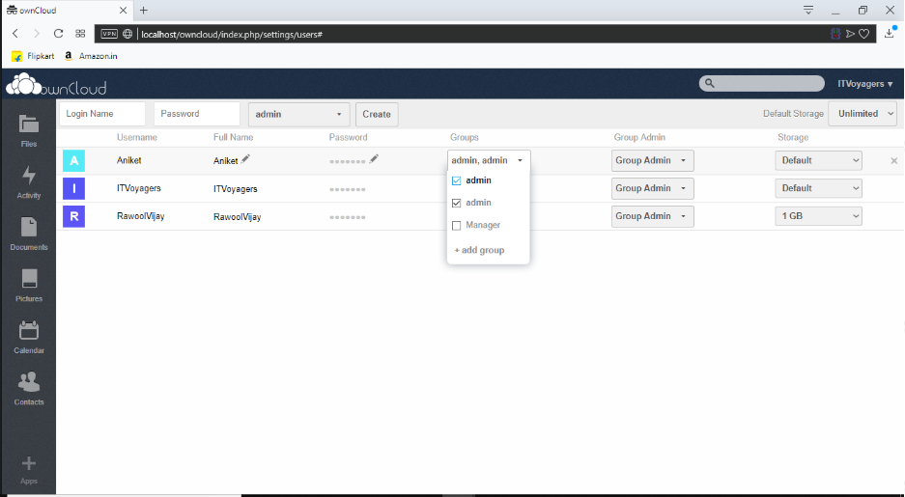

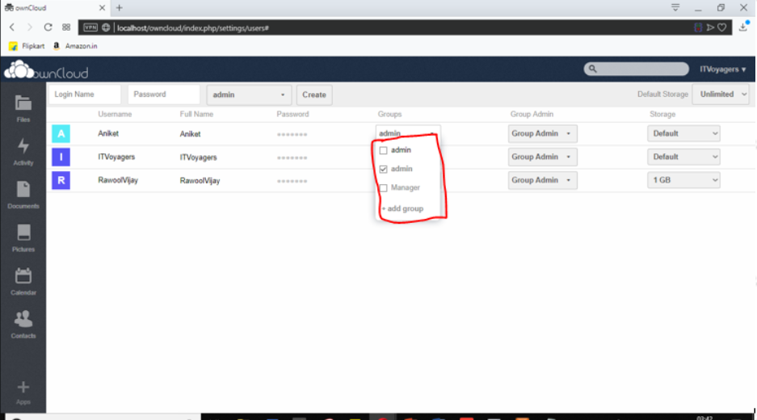

15.note:sometimes it fails to register user in “admin group so please check before logging out.you can check by refreshing page’

Now “logout” from the admin account

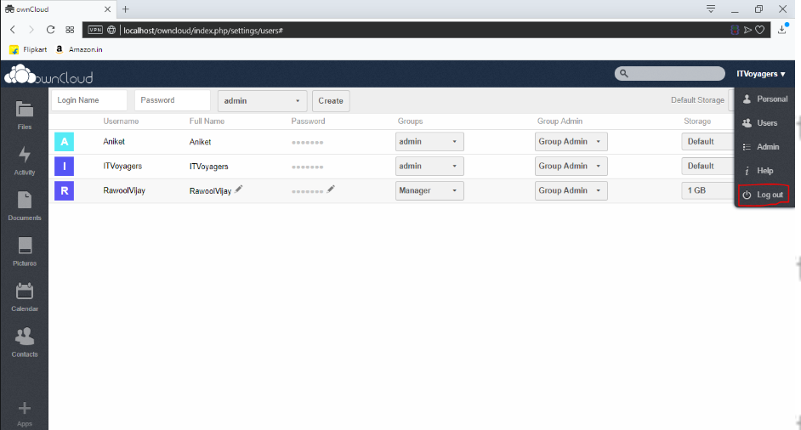

16.try log in with user just created

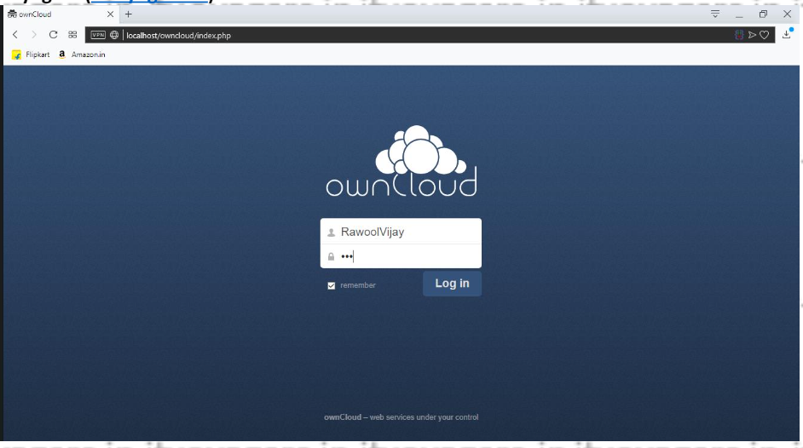

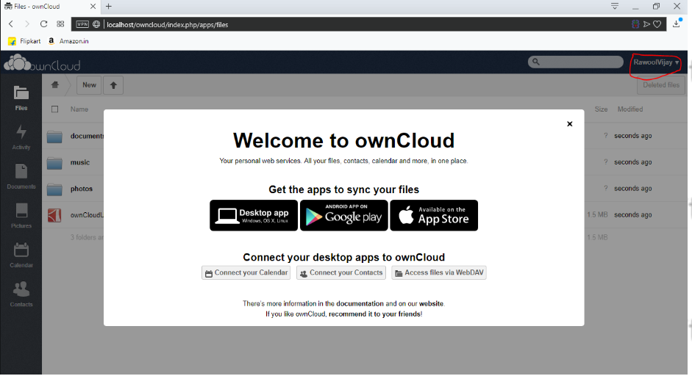

17.yes we have logged in

As you can see this user don’t have any privilege link adding users and creating group because its not in “admin”group,now “logout”from the account.

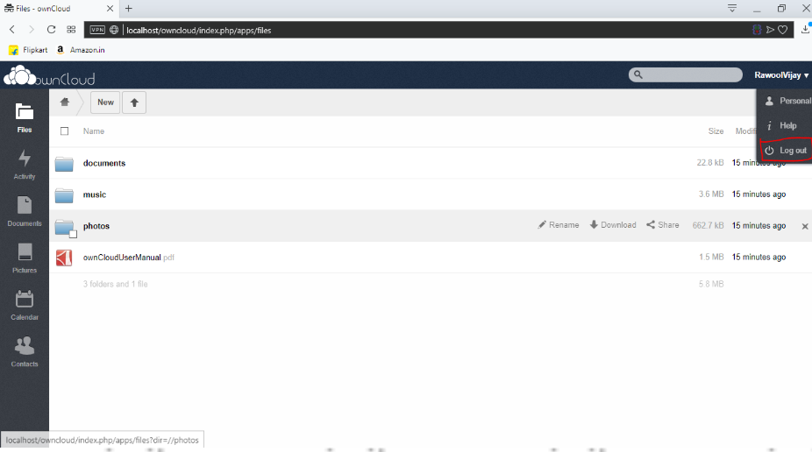

18.now lets try to login from the user account who is in “admin”group

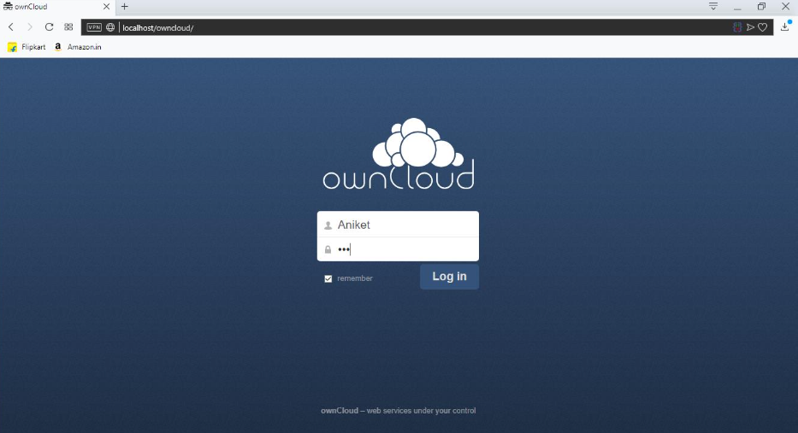

19.enter login details and click on “login”.

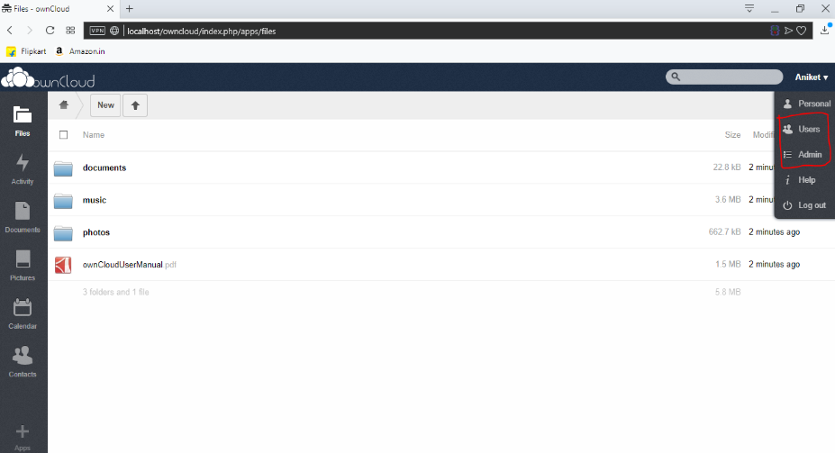

20.as you can see this user has the privilege then go to admin because he is in “admin”group

This user has all the rights that admin posses lik adding or deleting user.

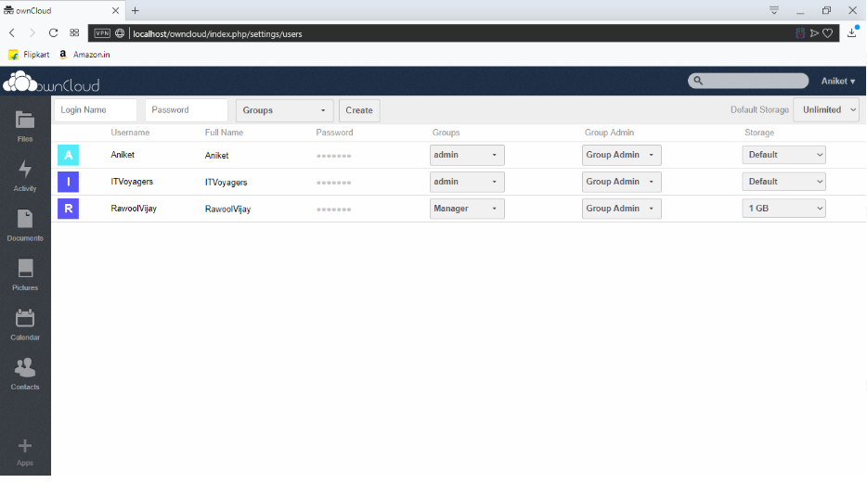

**PRACTICAL NO – 10**

**Case study on Amazon EC2/Microsoft Azure/Google Cloud Platform**

Amazon Web Services (AWS) is a collection of remote Computing services, also called web services that make up a cloud computing platform by Amazon.com. The most central and well-known of these services are Amazon EC2 and Amazon S3. The service is advertised as providing a large computing capacity (potentially many servers) much faster and cheaper than building a physical server farm.

**Benefits:-**

1. Easy to use:- AWS is designed to allow application providers, ISVs, and vendors to quickly and securely host your applications – whether an existing application or a new SaaS-based application. You can use the AWS Management Console or well-documented web services APIs to access AWS’s application hosting platform.
2. Flexible:- AWS enables you to select the operating system, programming language, web application platform, database, and other services you need. With AWS, you receive a virtual environment that lets you load the software and services your application requires. This eases the migration process for existing applications while preserving options for building new solutions.
3. Cost effective:- You pay only for the compute power, storage, and other resources you use, with no long-term contracts or up-front commitments. For more information on comparing the costs of other hosting alternatives with AWS, see the AWS Economics Centre.
4. Reliable:- With AWS, you take advantage of a scalable, reliable, and secure global computing infrastructure, the virtual backbone of Amazon.com’s multi-billion dollar online business that has been honed for over a decade.
5. Scalable and High Performance:- Using AWS tools, Auto Scaling, and Elastic Load Balancing, your application can scale up or down based on demand. Backed by Amazon’s massive infrastructure, you have access to compute and storage resources when you need them.
6. Secure:- AWS utilizes an end-to-end approach to secure and harden

our infrastructure, including physical, operational, and software measures. For more information, see the AWS Security Centre.

Application Solutions: - AWS offers a reliable and flexible cloud infrastructure platform that enables customers to run any type of business application, from small departmental solutions to mission- critical applications in a secure and robust environment.

Amazon Elastic Compute Cloud (EC2):- It is a central part of Amazon.com's cloud computing platform, Amazon Web Services (AWS). EC2 allows users to rent virtual computers on which to run their own computer applications. EC2 allows scalable deployment of applications by providing a Web service through which a user can boot an Amazon Machine Image to create a virtual machine, which Amazon calls an "instance", containing any software desired. A user can create, launch, and terminate server instances as needed, paying by the hour for active servers, hence the term "elastic". EC2 provides users with control over the geographical location of instances that allows for latency optimization and high levels of redundancy.

**Functions:-**

* Account Attributes AMIs
* AWS Marketplace Bundle
* Tasks Classic Link
* Customer Gateways (Amazon VPC)
* DHCP Options (Amazon VPC)
* Elastic Block Store
* Elastic IP Addresses
* Elastic Network Interfaces (Amazon VPC) Instances
* Internet Gateways (Amazon VPC) Key Pairs
* Network ACLs (Amazon VPC)
* Placement Groups
* Regions and Availability Zones
* Reserved Instances
* Route Tables (Amazon VPC) Security Groups
* Spot Instances Subnets (Amazon VPC) Tags
* VM Import
* VM Export
* VPCs (Amazon VPC)
* VPC Peering Connections (Amazon VPC) VPN
* Connections (Amazon VPC)
* Virtual Private Gateways (Amazon VPC)

HDM: - The company first launched in 1999 as "Hungama.com", a promotional marketing portal. In 2000 the company acquired India fm and in the following years began to work marketing campaigns for companies such as Coca-Cola and Nike.[3] In 2007 Hungama launched their gaming portal and in 2009, the company re-launched their website and company name, changing it to Hungama Digital Media Entertainment. In 2012 Hungama Digital Media Entertainment launched Artist aloud!, a digital platform for artists and music fans.

Challenges: - Before migrating to AWS, the company ran its servers in local data centers. This solution soon became expensive, time- consuming, and inefficient. Hungama wanted to turn projects around quickly but old equipment caused delays in implementation and service launches. In 2008, Hungama migrated to AWS to take advantage of the cost effectiveness, flexibility, and fast time-to-market offered by the cloud. “Our migration to AWS in 2008 reduced IT costs considerably,” says Amit Vora, CTO for Hungama. The cost savings allowed Hungama to focus its engineering resources on getting products and services to market more quickly. The company began to grow rapidly, but as more internal teams started using AWS, its monthly costs also grew. Hungama’s infrastructure team engaged AWS Support to help them find ways to optimize costs.

Solution by AWS: - As a content provider and aggregator, Hungama requires enormous amounts of storage. The company uses Amazon Simple Storage Service (Amazon S3) to host more than 60 TB of content. For server and storage management, Hungama uses Amazon Elastic Compute Cloud (Amazon EC2) and Amazon Relational Database Service (Amazon RDS) with Amazon S3. The flexibility of the AWS solution enables the Bollywood moviemaker to develop applications on multiple platforms and programming models including Java, PHP, .NET, Oracle, MySQL, and SQL technologies. As an AWS Support, Enterprise- level tier customer, Hungama has access to AWS Trusted Advisor, which customers can use to audit their AWS usage against known best practices. AWS Trusted Advisor identifies opportunities to save money, improve system performance, and security. Hungama used AWS Trusted Advisor to run Cost Optimizing checks, which audited Amazon EC2 instances and Amazon Elastic Block Store (Amazon EBS) volumes in Hungama’s environment.